 | Extreme Heat |  | Wildfire Smoke
Key Points | Very hot weather can make people sick. This happens when the temperature gets very hot quickly or when someone is in the heat for a long time. People who work outside or don’t have air conditioning are at high risk because they deal with the heat all day. Some people get sicker if they have health problems like asthma, heart disease, or diabetes.  There are different kinds of heat sickness. Mild heat sickness causes dizziness, headaches, or feeling very thirsty — this is called heat exhaustion. Serious heat sickness can cause confusion, slurred speech, passing out, or even seizures — this is called heat stroke. If you learn how to stay safe in hot weather, you can stay safe.  Who is at risk?  - Infants and children, older adults over 65 years old, pregnant people, people with heart, lung, or kidney problems, people with dementia, people with people with limited mobility, and people with mental health conditions, people who work outdoors, or who are experiencing homelessness.  How do I protect myself or family against heat illness?  - Make a plan for hot weather.  - Get the essentials ready, like extra water, cooling supplies, and extra medication.  - Know your options for staying cool, such as fans, AC, or places you can go.  - Keep up with the weather forecast in your area. |  | Wildfire smoke is made of tiny particles of dust, ash, and chemicals from man-made buildings that get burnt in the fire. These particles and chemicals are harmful when you breathe them in. Wildfire smoke can cause new health problems or make people sick who already have health problems.  Wildfire smoke causes sore throat, headache, painful or watery eyes, coughing, wheezing, chest pain, or trouble breathing.  Who is at risk?  - Infants and children, older adults over 65 years old, pregnant people, people with heart, lung, or kidney problems, people with dementia, people with people with limited mobility, and people with mental health conditions, people who work outdoors, or who are experiencing homelessness.  How do I protect myself or family against wildfire smoke?  - Make a plan for wildfires and wildfire smoke.  - Gather essentials and think about making a “go-bag” with extra medication.  - Protect your home — consider getting a HEPA air purifier or making a clean room.  - Stay informed and check the weather and air quality in your area.
Why this matters to your health
What is unsafe? | - The National Weather Service HeatRisk is a scale of the risk of getting sick from the heat. It measures the temperature and other weather conditions in the area.  - Heat Risk in Green/0 means the temperature is safe for everyone.  - Heat Risk in Yellow/1 and Orange/2 means the heat is unsafe for people with health problems. If you have heart problems, asthma, or COPD, it is important to keep cool. You should stay inside or go somewhere with air conditioning, like a mall or library.  - Heat Risk in Red/3 and Magenta/4 means the weather is too hot and unsafe for everyone. At this temperature, it will probably stay hot even at night. Drink lots of water, stay cool, and go to the hospital if you feel yourself getting too hot.  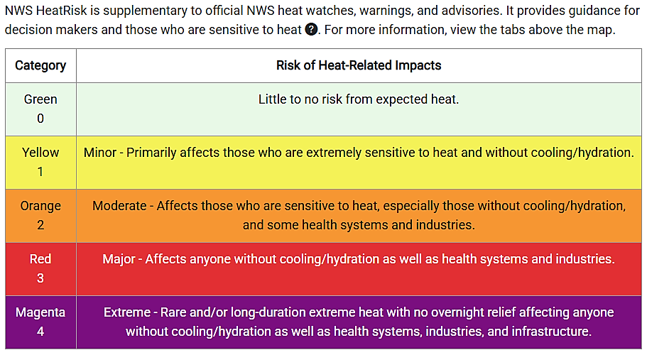  Figure 1: NWS HeatRisk Scale – https://www.wpc.ncep.noaa.gov/heatrisk/ |  | - Air Quality Index (AQI) is a scale that shows how clean or dirty the air is, based on how much pollution is in it.  - AQI 0–50 (green) means the air is good and safe for everyone.  - AQI 51–100 (yellow) means the air quality is okay; AQI 101–150 (orange) means the air is unhealthy for people who are sensitive to air pollution. These levels can cause sickness for people with heart or lung problems, young babies, or pregnant people.  - AQI 151–200 (red) is unhealthy; AQI 201–300 (purple) is very unhealthy. These levels can cause serious health problems for people who are sensitive to air quality. AQI between 151-300 can even cause healthy people to feel sick or have trouble breathing.  - AQI higher than 301 (maroon) is hazardous and can harm everyone’s health. This is an emergency. Pay attention to local news, weather, and emergency responders for instructions. If you must go outside, wear a respirator mask like an N-95.  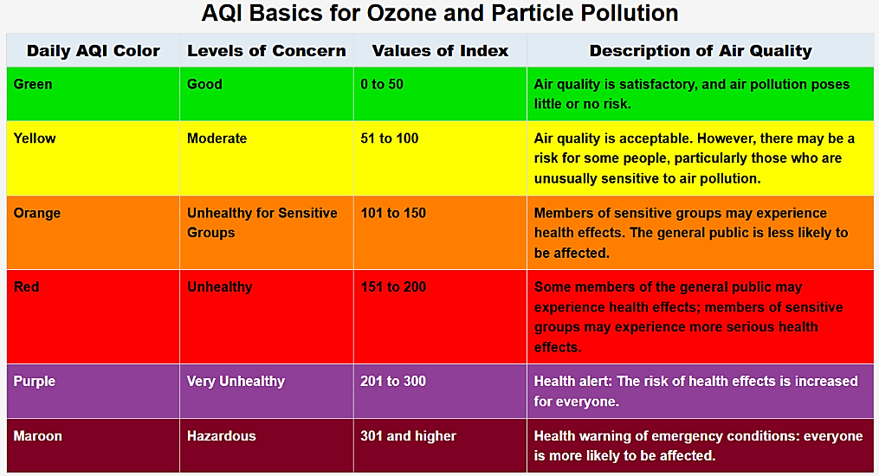  Figure 2: EPA AirNow Scale – https://www.airnow.gov/aqi/aqi-basics/
How to check risk today: | - National Weather Service NWS Heat Risk https://www.wpc.ncep.noaa.gov/heatrisk/  - You can find out how risky the temperature is by going to Heat.gov/heatrisk and clicking on “view tool/resource” halfway down the page.  - On the HeatRisk page, type in your address or ZIP code to see the heat risk for your area.  - If you normally check the weather on your local news, the weather channel, or a weather app, the HeatRisk scale will not be there. If this tool is helpful to you, bookmark the webpage or save it on your computer. Then you can check back on hot days. |  | - AQI is reported on most weather stations and weather apps as a number.  - Usually, weather apps and reports also explain what the number means— if the air is good or bad.  - You can also find the AQI at AirNow.gov. Type in your ZIP code, city, or state to see today’s AQI. Use the AQI Scale Legend on the left side of the screen to learn what the number means.  - You can also sign up notifications from AirNow – they will send you an email or text message with any air quality changes in your area.  Emails: https://www.enviroflash.info/signup.cfm  Text messages: https://www.enviroflash.info/cellproviders.cfm  More information: https://www.enviroflash.info/assets/pdf/EnviroFlash_factSheet.pdf
How to check risk today: | 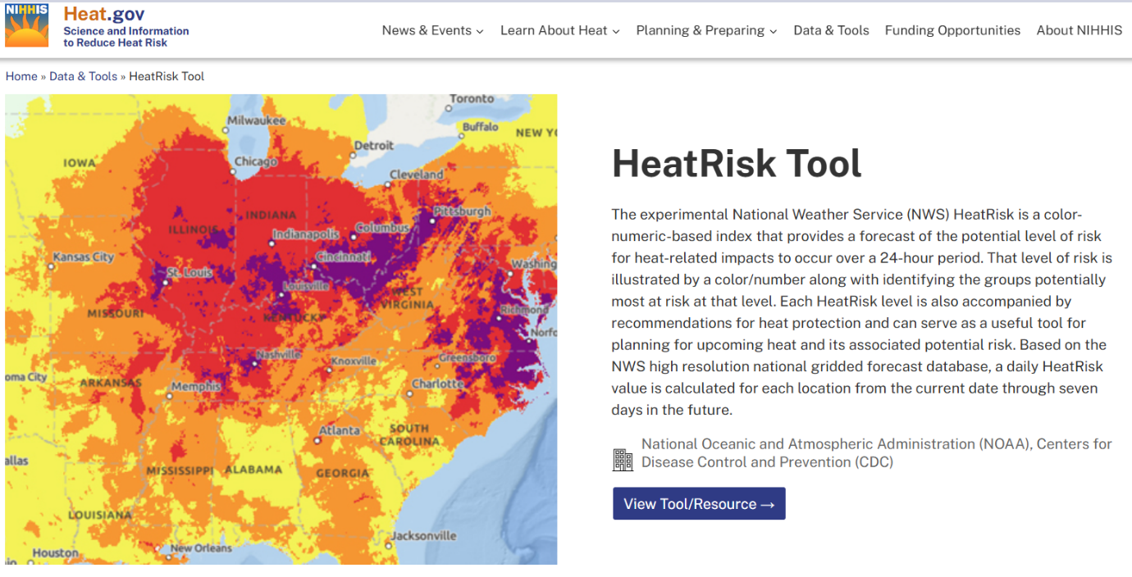  Figure 3: Heat.gov HeatRisk Tool Page - https://heat.gov/data-tools/heatrisk-tool/ |  | 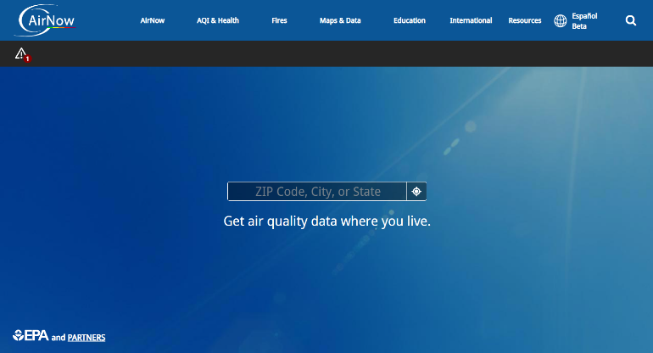  Figure 4 AirNow.gov Homepage - https://www.airnow.gov/? |  | 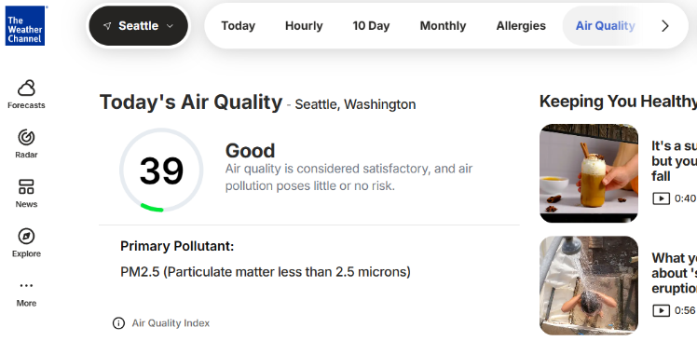  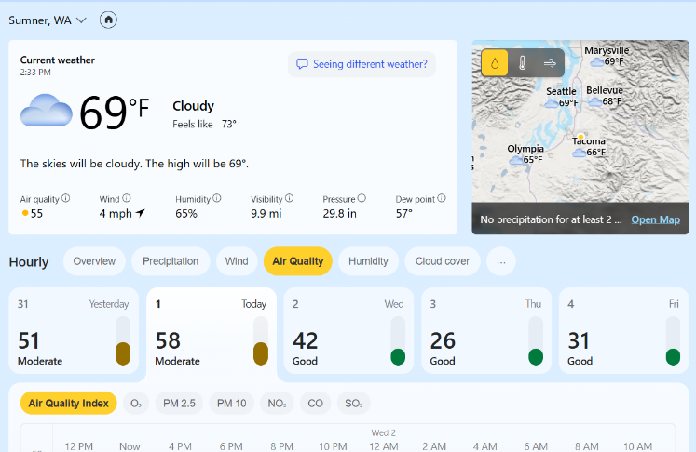  Figure 5: MSN Weather Air Quality Tab  Figure 6: The Weather Channel Air Quality Tab
How to check risk today: | 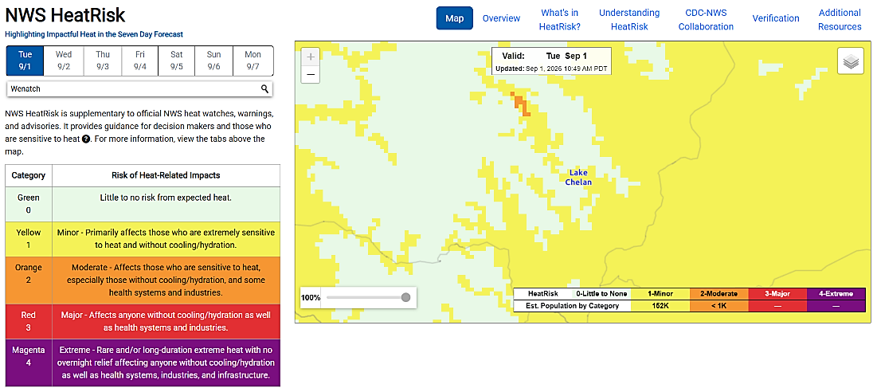  Figure 5: NWS HeatRisk Map – https://www.wpc.ncep.noaa.gov/heatrisk/ |  | 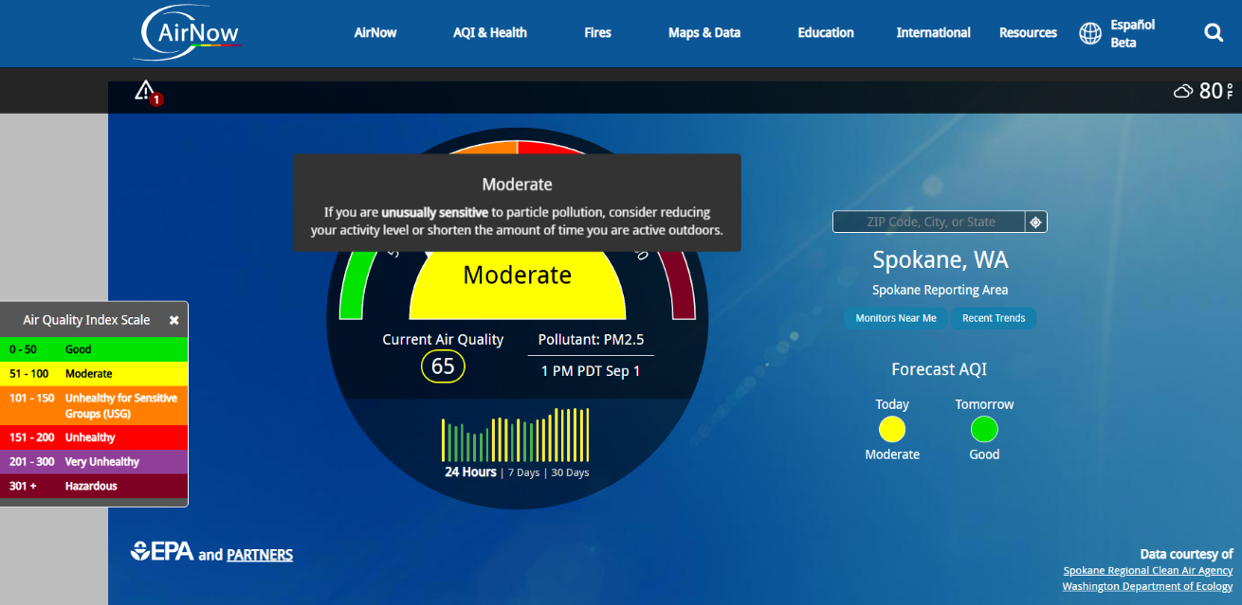  Figure 6: AirNow.gov AQI Forecast with AQI Index Scale and Explanation –
Am I at risk? | - Infants & children:  - Babies and children do not handle wildfire smoke well. Smoke can cause coughing, wheezing (a high pitched, whistling noise when breathing), trouble breathing, or lung infection (pneumonia).  - Babies and young children have a harder time keeping their body temperature normal. They can overheat and get dehydrated easily.  - You can cover strollers with a damp/slightly wet muslin cloth or blanket. Don't use dry cloths or blankets to cover strollers, this keeps hot air inside. You can also use a clip-on fan to keep strollers cool.  - Keep babies and children hydrated. Children should drink water, milk, or low sugar drinks. Babies should drink breast milk or formula. Breast-feeding parents should stay cool and drink plenty of fluids.  - Pregnant people:  - Extreme heat and wildfire smoke can both increase the chance of preterm labor and low birthweight; this means the baby could arrive premature or early and could be born small or underweight.  - Extreme heat can increase the chance of having a miscarriage. Extreme heat can also increase the chance of having Braxton-Hick’s contractions, also known as "false labor".  - People who are breastfeeding can get dehydrated faster. Drink lots of water and call your doctor if you don’t feel well.  - Adults 65+ years old:  - Older adults are more likely to have health problems that make wildfire smoke more dangerous. This can lead to more doctor visits, hospital stays, or even death.  - Older adults are also at higher risk of heat sickness. They are more likely to have health problems and take medicines that make it easy to overheat and get dehydrated. Some may not be able to keep their home cool or get supplies they need to stay hydrated.  - If your home is too hot, go somewhere safe and cool. Check on older neighbors, friends, or family during hot weather. If an older adult is confused, weak, pale, or has trouble walking, speaking, or staying awake, call 911 or go to the nearest hospital right away.  - People with Asthma, COPD, other lung diseases:  - Check the AQI every day to see if it is safe to be outside. AQI below 50 is usually safe. If AQI is above 50, limit time outdoors and talk to your doctor. If you must go outside, wear a respirator or mask.  - Wildfire smoke can make breathing problems worse, causing coughing, wheezing, and chest tightness. Heavy smoke causes people to use medicine more often and may also require more visits to the ER or more hospital stays.  - People with Heart Disease:  - Wildfire smoke increases the risk of heart attacks, heart failure, and irregular heartbeats. This can lead to ER visits, hospital stays, or even death.  - Hot weather puts extra stress on the heart and lungs. If you have heart failure or have had a heart attack, it is easier to get too hot or tired. Symptoms may include nausea, dizziness, or headaches.  - Check your weight every day and tell your doctor if you gain or lose more than two pounds in one day. If you take medicine like a water pill or diuretic - Lasix, furosemide, torsemide, or hydrochlorothiazide (HCTZ) - it is easier to get dehydrated. Ask your doctor how to stay hydrated.  - People with Kidney Disease:  - Wildfire smoke can make kidneys less effective at their job. Wildfire smoke makes people with kidney disease sick more quickly, this can cause kidney failure and dialysis.  - Extreme heat puts more stress on the kidneys and can cause damage. Drink plenty of water and check your urine — it should be light colored.  - People with Mental Illness:  - Hot weather can make it harder to sleep which can worsen mental health symptoms.  - Some medicine makes it hard for your body to cool down, including antipsychotics and antidepressants.  - People with Dementia  - People with dementia may not understand the danger heat or smoke causes. They need extra help to stay cool and hydrated.  - People with Multiple Sclerosis (MS)  - People with Multiple Sclerosis have a harder time keeping their body temperature normal.  - Extreme heat makes MS symptoms worse. Heat can make it harder to move, think clearly, or stay balanced. Staying cool is very important.
 | People with higher exposure to heat or smoke  This includes people who may have fewer resources or less ability to respond to danger:  - People who are homeless  - People who are incarcerated  - People with low incomes  - People who rent  - Marginalized communities | People who are physically active or who work in the heat or in spaces without good air flow  This includes athletes and many types of workers:  - Farmworkers, landscapers, grounds crew  - Postal workers, delivery drivers  - Warehouse workers, longshoremen,  - Linemen, utility workers  - Construction workers,  - Police officers, first responders, firefighters  - Anyone working outdoors or in hot indoor spaces |  | People taking certain medications  Some medicine makes it harder for your body to cool down or make it easier to get dehydrated. Ask your doctor or pharmacist if any of your medicine puts you at risk of heat sickness. Keep taking your medicine unless your doctor tells you otherwise. These medicines include:  - Antidepressants (SSRIs, SNRIs, tricyclics)  - Stimulants for ADD/ADHD  - Antipsychotics  - Anticholinergics (Cogentin, Oxybutynin, Diphenhydramine)  - Heart medicines (diuretics, beta/ calcium channel blockers, ACE inhibitors, ARBs)
How to keep yourself and family safe
How to  avoid  illness | Avoid heat exhaustion and heat stroke:  - Stay indoors in air-conditioned places as much as possible unless you are used to being in the heat. When you go outside, wear light layers of clothing.  - Drink plenty of fluids – water or low sugar electrolyte drinks if you are sweating a lot. Avoid drinks with caffeine, lots of sugar, or alcohol because they can dehydrate you.  - Eat light, healthy meals throughout the day to help your body stay strong in the heat.  - If you start to feel too hot, find a cool or shady place to sit, drink some water, and rest. If you don’t feel better, call 911 or go to the nearest emergency room right away. |  | Avoid illness from wildfire smoke:  - If wildfire smoke is in your area, stay indoors, keep windows and doors closed. If your home has HVAC, make sure your system is set to recirculate indoor air.  - Pay attention to local news or emergency alerts to learn if there is any fire danger nearby.  - If you must go outside, wear a respirator mask like an N95 or P100. Cloth or surgical masks will not protect you from smoke.  - Choosing the right mask: https://www.smokereadyspokane.org/how-tos/mask-tips
Plan with your healthcare team | - Ask your doctor about how heat or sun exposure might affect your health.  - Ask your pharmacist how to keep medicine safe during heat. This is very important if your medicine needs to stay cold, like insulin.  - Talk to your doctor or healthcare team about making emergency plans and what you should do if you feel sick.  - If you use medical equipment, you need a plan in case the power goes out. This includes things like oxygen, CPAP machines, or an electric wheelchair.
Staying safe at home | Keeping Your Home Safe  - If you have an AC system, check to make sure it is working early before the weather gets hot.  - Use light-colored window coverings and keep curtains closed during the day to help keep your home cool.  If the Power Goes Out or You Don’t Have AC  - Stay on the lowest floor and keep blinds closed to block sunlight.  - Use windows and fans to create airflow if the temperature and AQI are safe.  - Open windows only when the air quality and temperature are safe.  - Opening windows on different sides of the home can create a cross breeze.  - Opening upstairs windows can help hot air escape.  - A fan placed in one window can help cool a room.  - Keep water bottles in the freezer. If the power goes out, move them to the fridge and keep the doors closed.  - Keep battery or solar-powered flashlights, radios, and phone chargers.  - Try not to cook with the oven or stove because it heats up your home. Keep foods that don’t need much cooking. https://cottageatthecrossroads.com/recipes-to-cook-without-power/ |  | Keeping Indoor Air Clean During Wildfire Smoke  - Set-up a “clean room” in your house - one room in your home to keep smoke free. Close the windows and doors and use your HVAC system or a portable air cleaner to filter the air.  - Use an HEPA air filter and make sure it is clean before wildfire season.  - Keep windows closed if it is safe to do so with the heat.  - Keep indoor pollution low. Do not cook using the stove or oven. Do not smoke, burn wood, light candles or incense. Do not vacuum.
When I must go outside | Staying Safe in Hot Weather  - Try to do hard physical activity early in the morning or later in the evening when it’s cooler.  - Take lots of breaks when you are working, exercising, or playing outside. Rest in the shade or find a breeze if you can.  - Wear light-colored, loose-fitting clothes and a hat with a wide brim to block the sun. Use sunscreen to prevent sunburn and reapply it if you stay outside for more than two hours or go in the water.  - Avoid getting sunburned; sunburns make it harder for your body to cool down.  - If you start to feel signs of heat sickness, stop what you are doing right away and move to a cooler place. Drink cool water or a sports drink slowly. If you don’t feel better after a few minutes, get medical help right away. |  | Staying Safe in Wildfire Smoke  - Limit the time you spend outside.  - If you must go outdoors, wear a respirator mask like an N95 or P100. Do not wear a cloth mask or a surgical mask, this will not protect you from the tiny smoke particles.  - Bring a water bottle with you. Bring any rescue inhalers or medicines you might need.  - If there is a wildfire nearby, listen to local emergency responders and follow their instructions.
Works Cited | Environmental Protection Agency. (n.d.). AirNow AQI Monitor. https://www.airnow.gov/  Harvard T.H. Chan School of Public Health. (2024). Climate Resilience for Frontline Clinics Toolkit: Module for Wildfire and Smoke. https://www.americares.org/wp-content/uploads/WildfiresANDSmokeFullModule_Final0910.pdf  Harvard T.H. Chan School of Public Health. (2024). Climate Resilience for Frontline Clinics Toolkit: Module for Extreme Heat. https://www.americares.org/wp-content/uploads/ExtremeHeatCompleteModule_FINAL.pdf  Heat.gov. (n.d.) HeatRisk Tool. https://heat.gov/data-tools/heatrisk-tool/  National Weather Service and National Oceanic and Atmospheric Administration. (n.d.). NWS HeatRisk: Highlighting Impactful Heat in the Seven-Day Forecast. https://www.wpc.ncep.noaa.gov/heatrisk/  Smoke Ready Spokane. (n.d.). How to: Choosing the Right Mask. https://www.smokereadyspokane.org/how-tos/mask-tips  Western Fire Chiefs Association. (24 April 2024). Washington Fire Season: In-Depth Guide. https://wfca.com/wildfire-articles/washington-fire-season-in-depth-guide/

Resources
To help prepare | Extreme Heat  - Preparedness tips to get #SummerReady from ready.gov – addresses specific target audiences like low-income households, rural communities, older adults https://www.ready.gov/summer-ready  - WA DOH Preparedness Information https://doh.wa.gov/emergencies/be-prepared-be-safe/severe-weather-and-natural-disasters/extreme-heat/hot-weather-precautions  - Americares Climate Resilience Toolkit Heat Action Plan & Tip Sheet – guide to creating a plan for extreme heat: https://www.americares.org/wp-content/uploads/ExtremeHeat_ActionPlanTipSheet_Final.pdf  - Be Heat Smart – WA Labor & Industries Safety Program: https://lni.wa.gov/safety-health/safety-training-materials/workshops-events/beheatsmart  Wildfire smoke  - Washington Smoke Blog https://wasmoke.blogspot.com/  - Resources and information on air filters: https://doh.wa.gov/community-and-environment/air-quality/indoor-air/portable-air-cleaners  - How to make a low-cost air purifier for your home, English & Spanish: https://pnash.deohs.washington.edu/sites/pnash/files/2023-09/AirFilterInfographic_FINAL_EnSpn.pdf  - How to make a low-cost air purifier for your home – video: https://sites.uw.edu/jaffe-group/smoke-wildfire-resources/how-to-make-a-low-cost-air-purifier-for-your-home/  - EPA DIY Air Cleaner multiple designs and levels: https://www.epa.gov/system/files/documents/2023-08/DIY%20Air%20Purifier%20Infographic_508%20Compliant.pdf  - Americares Climate Resilience Toolkit Wildfire Smoke Action Plan & Tip Sheet – guide to creating a plan to prepare for wildfire smoke: https://www.americares.org/wp-content/uploads/WildfiresSmokeActionPlanTipSheet_Final.pdf  - Americares Climate Resilience Toolkit Wildfire Action Plan & Tip Sheet – guide to creating a plan to prepare for wildfires: https://www.americares.org/wp-content/uploads/WildfireActionPlanTipSheet_FINAL.pdf  - WA Labor & Industries Wildfire Smoke Education: https://lni.wa.gov/safety-health/safety-topics/topics/wildfire-smoke#overview  - How and why to wear a respirator: https://www.epa.gov/sites/default/files/2018-11/documents/respiratory_protection-no-niosh-5081.pdf  Both Extreme Heat & Wildfire Smoke, or Personal Preparedness  - Personal Preparedness in 30 Days – NW Healthcare Response Network: https://nwhrn.org/wp-content/uploads/2025/08/Personal_Preparedness_in_30_days_2025.pdf  - For Washingtonians with Access & Functional Needs: https://mil.wa.gov/afn  - Preparing for Power Outage with Medical Equipment https://46103627-2218-404d-a28f-c3dac82575c7.usrfiles.com/ugd/461036_d202b3d9cdf045ae8c05acd1ca71edbf.pdf  - Caregiver preparedness https://www.ready.gov/sites/default/files/2024-02/ready-gov_caregivers-preparedness-guide.pdf#:~:text=In%20this%20step%2C%20you%20will%20learn%20the%20essential,disaster%20preparedness%20planning%20or%20engaging%20your%20support%20network.
For real-time reliable info | - Washington Health Alert Network (DOH):  https://doh.wa.gov/public-health-provider-resources/washington-health-alert-network  - Extreme Weather Shelters Resource Bridge - https://dev-bridge.hsl.washington.edu/weather/extreme-weather-shelters/ | - Washington Health Alert Network (DOH):  https://doh.wa.gov/public-health-provider-resources/washington-health-alert-network  - Washington Smoke Blog: https://wasmoke.blogspot.com/
Learn more | - Heat.gov – Science and Information to Reduce Heat Risk: https://heat.gov/ | - Southwest Clean Air Agency: https://www.swcleanair.gov/

Resources by AppleCare Integrated managed care regions or County
Spokane Region | Spokane County  - Smoke Ready Spokane: https://www.smokereadyspokane.org/  - Smoke Ready Spokane Checklist: https://www.smokereadyspokane.org/checklist  - Smoke Ready Spokane Toolkits: https://www.smokereadyspokane.org/toolkit  - Spokane Regional Health District – Extreme Heat: https://srhd.org/health-topics/environmental-health/extreme-heat  - Cooling Centers Map – Gonzaga University Institute for Climate, Water, and the Environment: https://gonz.maps.arcgis.com/apps/webappviewer/ index.html?id=f1e9424b84954502ba1163b9765480dd&extent=-13198140.5003%2C5973955.3809%2C-12919451.0952%2C6128205.3039%2C102100  - Cleaning up After a Wildfire: https://srhd.org/health-topics/environmental-health/wildfire-smoke/after-a-wildfire  Stevens County  - Wildfire Resources for Stevens County https://www.stevenscountywa.gov/20859/emergency-management  - Extreme Heat Resources for Stevens County https://www.stevenscountywa.gov/21464/Extreme-Heat  Resources needed for: Ferry County, Pend Oreille County, Lincoln County, Adams County
North Central Region | Okanogan County  - Okanogan County Public Health Wildfire and Smoke readiness https://www.okanogancounty.gov/503/Wildfire-Fire-Smoke-readiness  - Recommendations for protecting health after a wildfire: https://www.okanogancounty.gov/DocumentCenter/View/1844/Guidelines-for-Protecting-Your-Health-After-a-Wildfire-PDF?bidId=  Douglas & Chelan County  - Wildfire Smoke Resources for Agricultural Families in Chelan Co: https://pnash.deohs.washington.edu/wildfire-smoke-resources-agricultural-families-chelan-county  - Chelan-Douglas Health District – Wildfire Smoke: https://www.cdhd.wa.gov/wildfire-smoke  - Chelan-Douglas Health District – Summer Heat: https://www.cdhd.wa.gov/summer-heat  - Chelan PUD Services – how to smoke-proof your home: https://www.chelanpud.org/conservationhome/residential/resources/indoor-air  Grant County  - Grant County Health District Extreme Heat: https://granthealth.org/159/Extreme-Heat  - Grant County Health District Wildfire Smoke: https://granthealth.org/160/Wildfires-Smoke  - Grant County Health District Preparedness: https://granthealth.org/158/Be-Prepared-for-Emergencies
Greater Columbia Region | Whitman County  - Air Quality Page, updates AQI daily – Public Health: https://whitmancountypublichealth.org/environmental-health/hazards-and-toxics/air-quality/  - Wildfire Smoke Informational Flyer: https://whitmancountypublichealth.org/assets/general/Air-Quality-Flyer-2.pdf?v=1718126518  - Extreme Heat Page, includes cooling stations - https://whitmancountypublichealth.org/environmental-health/hazards-and-toxics/extreme-heat  - Extreme Heat Informational Flyer: https://whitmancountypublichealth.org/assets/general/WCPH-Extreme-Heat-Flyer.pdf?v=1729539739  Garfield County  - Garfield Co Public Health – Extreme Heat https://www.garfieldcountywa.gov/publichealth/page/extreme-heat  - Guidance on Outdoor Activity in Excessive Heat from Garfield Co https://www.garfieldcountywa.gov/media/5436  Walla Walla County  - Walla Walla County Department of Community Health – Extreme Heat Page https://dch.wwcowa.gov/emergency_preparedness/extreme_heat.php#collapse13521b2  - Walla Walla County Department of Community Health – Air Quality Page https://dch.wwcowa.gov/emergency_preparedness/air_quality.php  Resources needed for: Asotin County, Columbia County, Benton County, Franklin County, Yakima County, Kittitas County
Southwest Region | - Washington Gorge Action Programs – Klickitat and Skamania Co Cooling Centers https://www.wagap.org/cooling-centers  Klickitat County  - Klickitat County Wildfire Resource Hub – Smoke Resource https://www.wildfirereadyklickitat.org/smoke  - Klickitat County Wildfire Resource Hub – Protecting Your Home https://www.wildfirereadyklickitat.org/protecting-your-home  Skamania County  - Skamania County Extreme Heat & Cooling Centers: https://www.skamaniacounty.gov/departments-offices/community-health/public-health/emergency-preparedness-and-response-program/extreme-heat  - Skamania County Air Quality & Wildfire Smoke: https://www.skamaniacounty.gov/departments-offices/community-health/public-health/emergency-preparedness-and-response-program/emergency-preparedness-and-response  Clark County:  - Clark County Public Health – Hot Weather Safety: https://clark.wa.gov/public-health/hot-weather-safety  - Clark County Public Health – Smoke from wildfires: https://clark.wa.gov/public-health/smoke-wildfires  - Be Ready Vancouver: Emergency preparedness in Vancouver, homepage for heat, wildfire smoke, flooding, volcanoes, etc: https://www.cityofvancouver.us/community/be-ready-vancouver/  - Extreme Heat: Are you ready? https://www.cityofvancouver.us/community/be-ready-vancouver/extreme-heat-are-you-ready/  - Vancouver Cooling Centers & Extreme Heat Resources: https://www.cityofvancouver.us/extreme-heat-hot-weather/  - Wildfires and Smoke: Are you ready? https://www.cityofvancouver.us/community/be-ready-vancouver/wildfires-and-smoke-are-you-ready/
North Sound Region | Snohomish County:  - Snohomish County Hot Weather Cooling Stations https://www.snohd.org/228/Weather  - Snohomish County Keeping Cool in Hot Weather https://www.snohd.org/DocumentCenter/View/7673/Keeping-Cool-FL?bidId=  - Snohomish County Public Safety Hub – alerts, air quality updates, cooling shelter information: https://snohomish-county-public-safety-hub-snoco-gis.hub.arcgis.com/  - SnoCo Alerts: Emergency texts/calls from 911 for Snohomish Co: https://www.smart911.com/smart911/ref/reg.action?pa=snohomish  Whatcom County:  - Extreme Heat Response Plan Template - https://www.whatcomcounty.us/DocumentCenter/View/98800/Extreme-Heat-Response-Plan  - Whatcom County Health and Community Services Extreme Heat https://www.whatcomcounty.us/3991/Extreme-Heat  - Wildfire Smoke Response Plan Template - https://www.whatcomcounty.us/DocumentCenter/View/98799/Wildfire-Smoke-Response-Plan  - Heat resources video: https://www.youtube.com/watch?v=jwq7QsSkOLM&feature=youtu.be  - Whatcom County Health and Community Services Wildfire Smoke https://www.whatcomcounty.us/3308/Wildfire-Smoke  - Building Resistance Against Smoke and Heat https://storymaps.arcgis.com/stories/d49b0b0b88e34519be977ffd0ca650d7  - Wildfire Smoke video: https://www.youtube.com/watch?v=t2i-LmZ9nLM  Island County  - Island County Cooling Centers https://www.islandcountywa.gov/767/Cooling-Centers-in-Island-County  - Preparing for Extreme Heat https://www.islandcountywa.gov/765/Preparing-for-an-Extreme-Heat-Event  - Preparedness and emergency alerts https://www.islandsready.org/  Resources needed for: Skagit County, San Juan County
King | - Extreme Heat Emergency Preparedness – King Co Government https://kingcounty.gov/en/dept/executive-services/health-safety/safety-injury-prevention/emergency-preparedness/extreme-heat  - Hot weather preparedness, Seattle King County Public Health – multiple resources, multiple languages, multiple formats including comics, brochures, videos: kingcounty.gov/beattheheat  - Pet and animal tips during summer heat: https://kingcounty.gov/en/dept/executive-services/animals-pets-pests/regional-animal-services/pet-tips  - King Co Regional Homelessness Authority – Severe Weather Response, overnight and daytime shelter space: https://kcrha.org/severe-weather-shelter/  - Wildfire Smoke Preparedness, Seattle King County Public Health – multiple resources, multiple languages, multiple formats including comics, brochures, videos: kingcounty.gov/wildfiresmoke
Pierce | - Keep Cool - Tacoma-Pierce Co Health https://tpchd.org/homes/emergency-preparedness/hot-weather/  - Hot Weather Information, includes Cooling Centers – translated into multiple languages and ASL https://www.piercecountywa.gov/6226/Hot-Weather-Information  - Find Shelter – Pierce County https://www.piercecountywa.gov/8220/Find-Shelter#extreme-weather  - Heat exhaustion vs Heat Stroke info sheet https://tpchd.org/wp-content/uploads/2023/12/Heat-Exhaustion-vs-Heat-Stroke.pdf  - Ready – get alerts about extreme weather, heat, and wildfire smoke in the area https://www.piercecountywa.gov/ready#alert  - City of Tacoma Inclement Weather Resource https://tacoma.gov/services/inclement-weather-resources/  - Wildfire Smoke – Tacoma-Pierce Co Health, fliers in multiple languages https://tpchd.org/environment/outdoor-air/wildfire-smoke/  - Other Outdoor air-quality resources https://tpchd.org/environment/outdoor-air/
Thurston-Mason | Thurston County:  - Heat Safety: https://www.thurstoncountywa.gov/departments/public-health-and-social-services/environmental-health/heat-safety  - Cooling Centers: https://www.thurstoncountywa.gov/departments/emergency-management/threats-hazards/extreme-heat/cooling-centers  - Air Quality – Smoke & Wildfire https://www.thurstoncountywa.gov/departments/public-health-and-social-services/environmental-health/air-quality  - Personal Planning worksheets for Extreme Hit and Wildfire Smoke https://s3.us-west-2.amazonaws.com/thurstoncountywa.gov.if-us-west-2/s3fs-public/2026-05/Climate%20Resilience%20Toolkit_TCPHSS%20%285%29%20%281%29.pdf  Resources needed for Mason County  - Olympic Region Clean Air Agency https://www.orcaa.org/air-quality-alert-issued-for-thurston-mason-county/
Salish Region | Kitsap County  - Cooling & Severe Weather Shelters: https://www.kitsapdem.com/programs/severe-weather-shelter/  - Kitsap Public Health Wildfire Smoke https://www.kitsappublichealth.org/phepr/smoke  - Kitsap Public Health https://www.kitsappublichealth.org/phepr/heat  Jefferson County  - Jefferson County Public Health Heat https://jeffersoncountypublichealth.org/1654/Heat  - Jefferson County Public Health Wildfire Smoke – includes video of in person wildfire smoke training https://www.jeffersoncountypublichealth.org/1652/Wildfire-Smoke
Great Rivers Region | Lewis County  - Understanding Wildfire Smoke Lewis County Public Health & Social Services https://lewiscountywa.gov/media/documents/Wildfire_Smoke.pdf  Wahkiakum County  - Sign up for emergency alerts and cooling shelter notification - https://www.co.wahkiakum.wa.us/198/Emergency-Management  Resources needed for: Clallam County, Cowlitz County, Pacific County, Grays Harbor County
How can your MCO help? | - CHPW – How to Stay Healthy When the Air is Smoky: https://connections.chpw.org/illness-prevention/2024/how-to-stay-safe-and-healthy-during-wildfire-smoke
