**Directions to University District Industrious Office for the Bree September Retreat**

University District Industrious office is located on 4311 11th Ave NE, Seattle, WA 98105 on 11th Ave NE between 43rd and 45th street.

Front of building – enter lobby here:

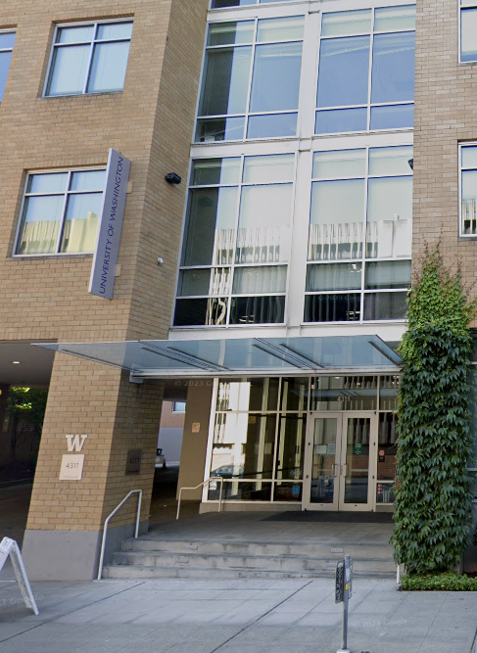

Take elevator up to the 5th floor for the Industrious lobby and front desk. **Our meeting room will be on floor 6 (room 601).** Please call Karie Nicholas (206.204.7380) for help getting in the building.

In-office amenities include coffee, tea, water and snacks. Visitor Wi-Fi access is available without a passcode.

**Transportation**

Parking

• The closest parking lot is Diamond parking on 43rd Street between 11th Ave NE and Roosevelt Way NW – validation not provided

Bus

• Office is very close to multiple bus lines. Check on-line to determine the closest location and

your preferred route.

Light Rail

• The office is about 2 blocks away from the University District light rail stop