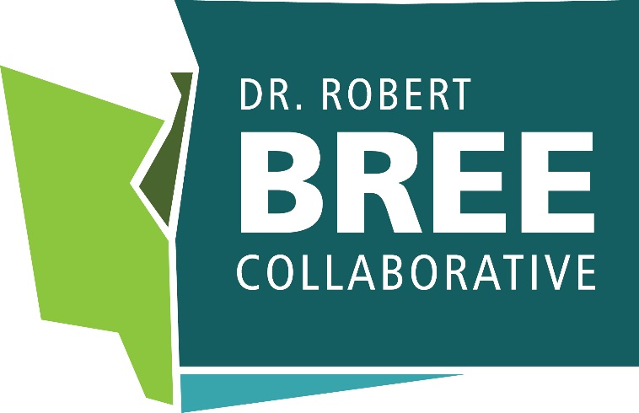

Working together to improve health care quality, outcomes, affordability, and equity in Washington State.

Blood Pressure Screening and Control
2025

Glossary 7
Executive Summary 8
Key Priorities 9
Stakeholder-Specific Guidelines 11
Primary Care Settings and Professionals 11
Specialty Outpatient Clinics 15
Hospitals 15
Health Plans 17
Employers and Health Care Purchasers 19
State Agencies 21
Community Pharmacies 23
Dental Clinics/Dentists 23
Evidence Review 26
Blood Pressure Control in Context 26
Towards Universal Blood Pressure Screening 28
Blood Pressure Self-Management 31
Team-Based Care 31
Access to Validated Blood Pressure Cuffs 34
Alternative Payment Mechanisms to Support Whole-Person Hypertension Care 34
Measurement 35
Washington State Initiatives 36
Appendices 39
Appendix A. Guidelines and Systematic Review Search Results 39
Appendix B. Bree Collaborative Members 48
Appendix C. Blood Pressure Control Charter and Roster 49
Appendix D Routine Lab Testing for New Diagnosis of Hypertension & Secondary Causes of Hypertension 52
Appendix E. Workflow Directing Threshold and Recommendations for Treatment and Follow Up 54
Appendix F. Hypertension Medications with Potential Dental Treatment Interactions 54
Appendix G. Community-based Screening through Delivery Systems 57
References 58

Glossary
ABPM: Ambulatory Blood Pressure Monitoring
BMI: Body Mass Index
BP: Blood Pressure
CDC: Centers for Disease Control and Prevention
CVD: Cardiovascular Disease
DASH: Dietary Approaches to Stop Hypertension
EMR/EHR: Electronic Medical Record/Electronic Health Record
HBPM: Home Blood Pressure Monitoring
HTN: Hypertension
LHJ: Local Health Jurisdiction
QALY: Quality-Adjusted Life Year
SDOH: Social Determinants of Health
USPSTF: United States Preventive Services Task Force

Executive Summary
Hypertension impacts about half of American adults, while only around a quarter have their hypertension under control. Hypertension prevalence and control varies between subpopulations, and these inequities are rooted not only in contemporary social and economic barriers but also in a long history of systemic racism, structural discrimination, and inequitable access to conditions that promote health.,,
Policies and practices such as redlining (residential segregation by race), underinvestment in communities of color, and exclusion from economic and educational opportunities have shaped the environments in which people live, work, and age. This environment influences diet, physical activity, housing access and quality, exposure to environmental stressors, and access to health care—factors all closely linked to risk for chronic conditions like hypertension. In addition, chronic stress associated with discrimination has been linked to hypertension, through physiological and behavioral pathways, compounding the effects across generations.
Eliminating these inequities in Washington state will take coordinated, multilevel strategies that span sectors outside of healthcare. However, the healthcare ecosystem has the responsibility to address inequities in care for the communities they serve and can support significant improvement and healing through partnership. This report and set of guidelines focuses on the healthcare ecosystems’ role in addressing hypertension control and equity, including the identified strategies outlined in our focus areas. Readers should review the executive summary, key takeaways, and the stakeholder specific guidelines that reflect their specific organization, (e.g., a primary care provider should read the healthcare professionals guidelines) then review the rest of supporting sections. The workgroup identified the following focus areas and key priorities for each stakeholder audience below:
- Blood Pressure Screening
- Individualized Blood Pressure Management
- Integrated Team-based Care
- Quality Improvement and Data Insights

Key Priorities
The workgroup recommends the following key priorities for each stakeholder:
Stakeholder | Key Takeaways
All Stakeholders | - Universally and accurately screen every person’s blood pressure at every opportunity  - Connect those with potentially undiagnosed or uncontrolled hypertension to care as soon as possible  - Identify and intervene to eliminate disparities in hypertension screening and control wherever possible  - Empower individuals to manage their own blood pressure at home, and educate on importance of blood pressure control  - Recommend evidence-based treatment approaches that are aligned with national guidelines and tailored to individual needs and circumstances  - Promote and participate in team-based care to improve access and equity  - Collect and use data for quality improvement (e.g., registries, performance metrics, etc.) to drive elimination of disparities in hypertension
Primary Care Settings | - Accurate blood pressure measurement and validation techniques for home monitoring; embracing self-measured blood pressure (SMBP) monitoring  - Screen for hypertension at every opportunity, and refer to primary care for follow up within 2 weeks for those with a blood pressure >/= 130/80 mmHg  - Collaboratively set hypertension goals with the patient and support system  - Engage in shared decision-making discussions about medication management if blood pressure not improved within 3-6 months of initiating treatment  - Implement team-based care and tools to support population management
Outpatient Specialty Care Settings | - Accurate blood pressure measurement  - Screen for hypertension at every opportunity, and refer to primary care for follow up within 2 weeks for those with a blood pressure >/= 130/80 mmHg
Hospitals | - Accurate blood pressure measurement  - When possible, provide coordination with primary care for all patients who are discharged with diagnosed uncontrolled hypertension
Health Plan | - Supply validated blood pressure cuffs to members with hypertension  - Utilize value-based payment mechanisms that reimburse for member outcomes instead of services  - Whole-person approach to care  - Identifying and reaching out to members with hypertension that experience care gaps (e.g., medication lapses)  - Cover care from nonphysician team members (community health worker, pharmacist) and comprehensive virtual/digital care and monitoring
Employer | - Minimize cost-sharing for first-line medications and nonpharmacological interventions for chronic conditions  - Prioritize performance guarantees focused on closing gaps in BP control across population subgroups  - Educate employees on how to use benefits to purchase validated home blood pressure monitors (through health plan benefit, flexible spending account (FSA) or health savings account (HSA))
Community Pharmacies | - Accurate blood pressure measurement  - Label for-purchase home blood pressure monitors that are validated  - Consider offering home blood pressure measurement/self-monitoring programs
WA HCA | - Include single pill combination medication on single preferred drug list when possible  - Promote value-based payment that includes stratified blood pressure control metrics
WA DOH | - Convene partners to develop health education and education campaigns promoting blood pressure management across communities  - Promoting access to community-based blood pressure screening and connection to care  - Aggregate and publicly share data on community hypertension prevalence and control  - Support and partner on clinical quality improvement projects aimed at improving population blood pressure control.
Dentists | - Accurate blood pressure measurement with validated upper arm cuff  - Escalation and coordination of care for people with elevated blood pressure  - Documentation of blood pressure in electronic dental record and data sharing with primary care health systems as able

Hypertension Control
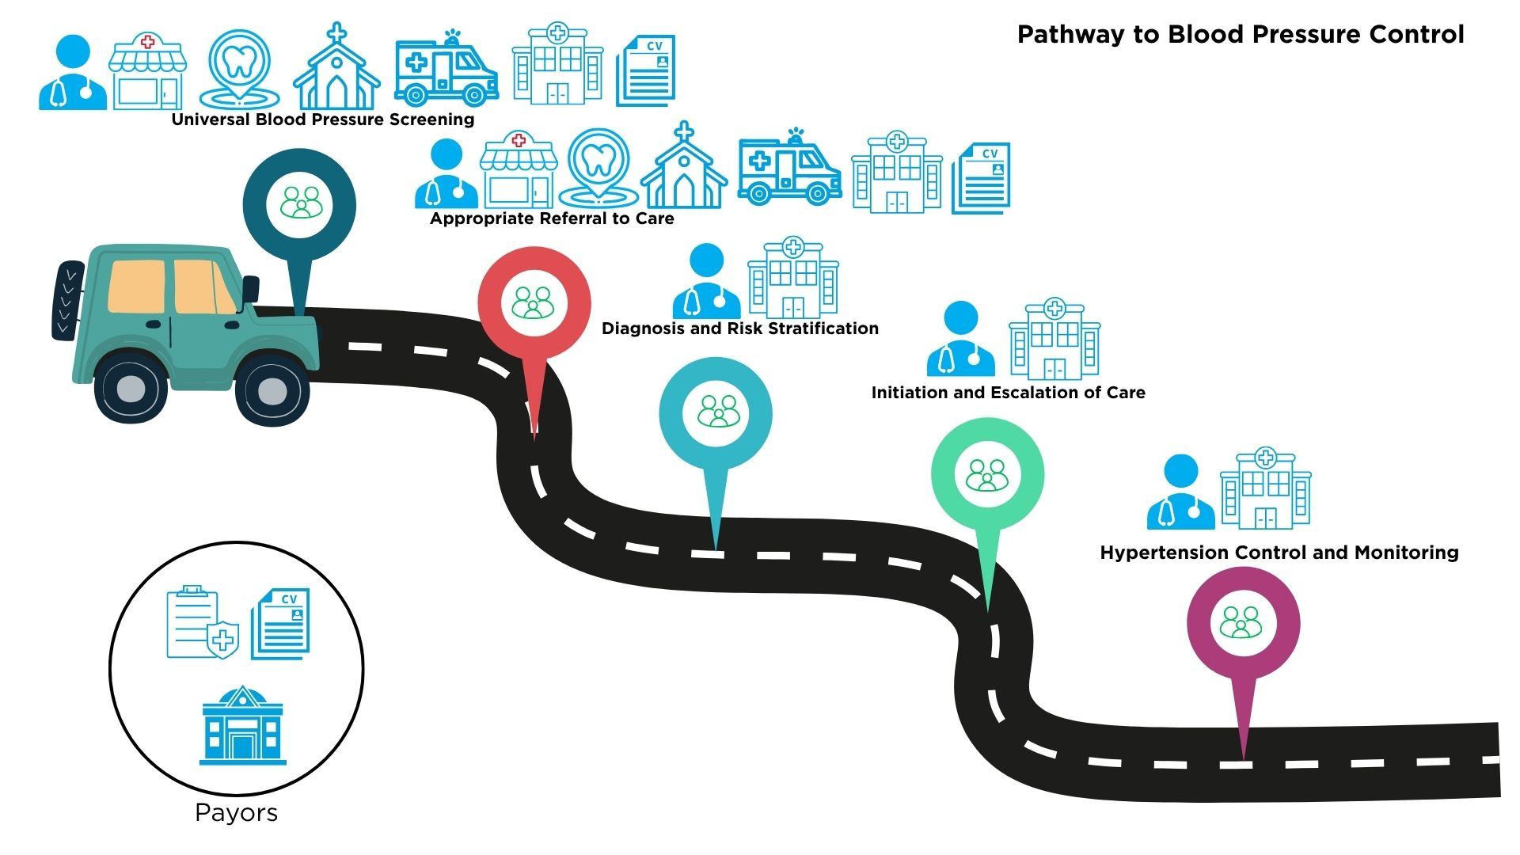

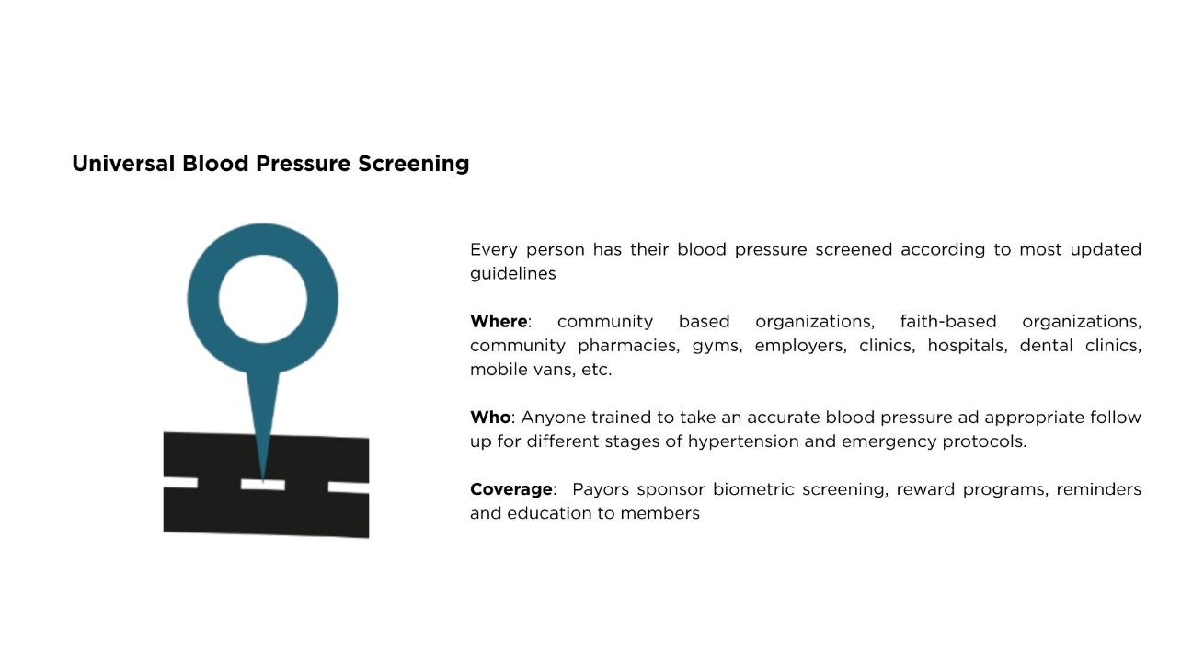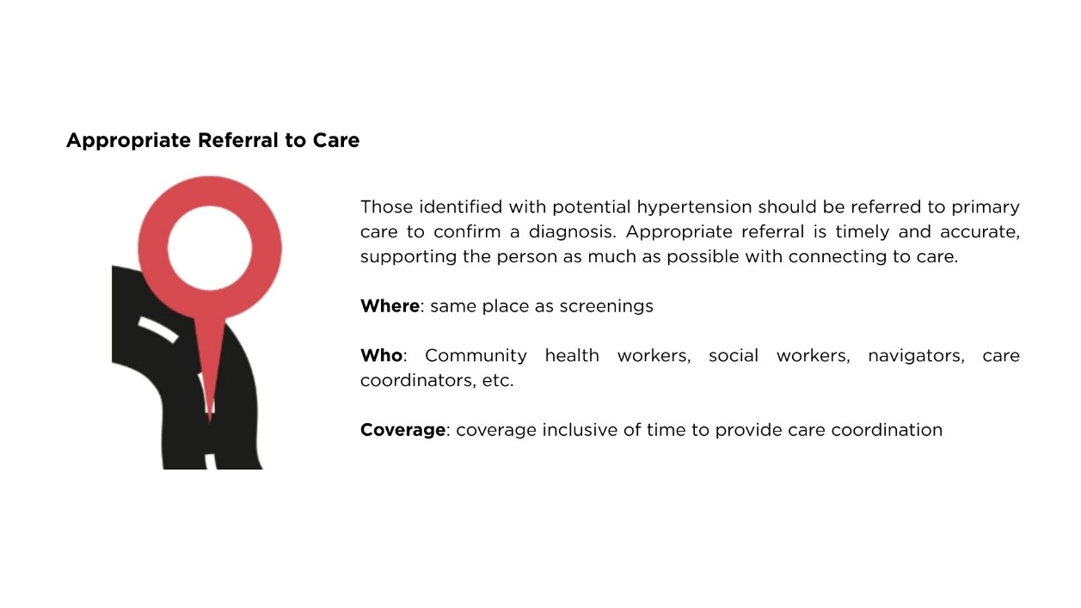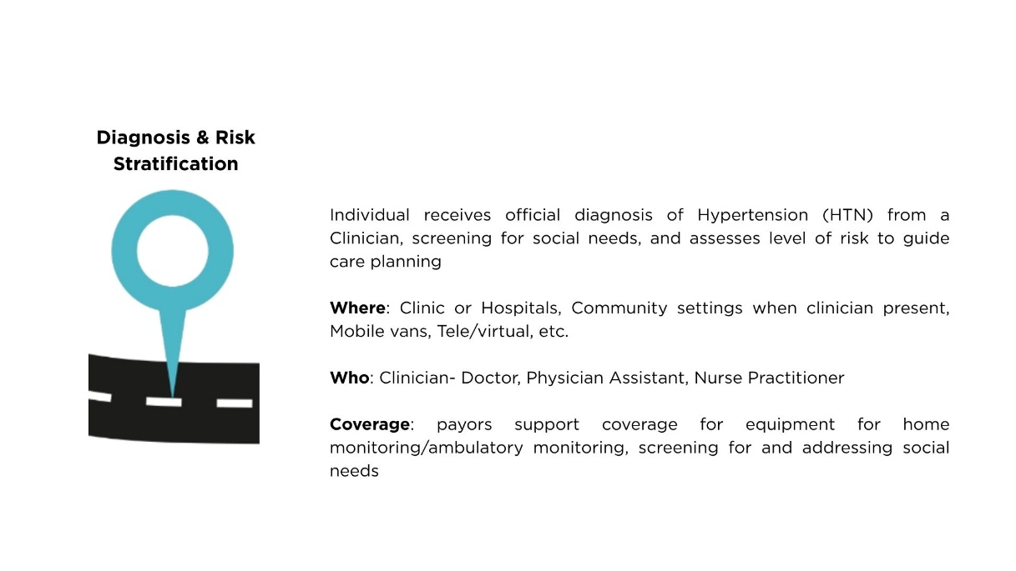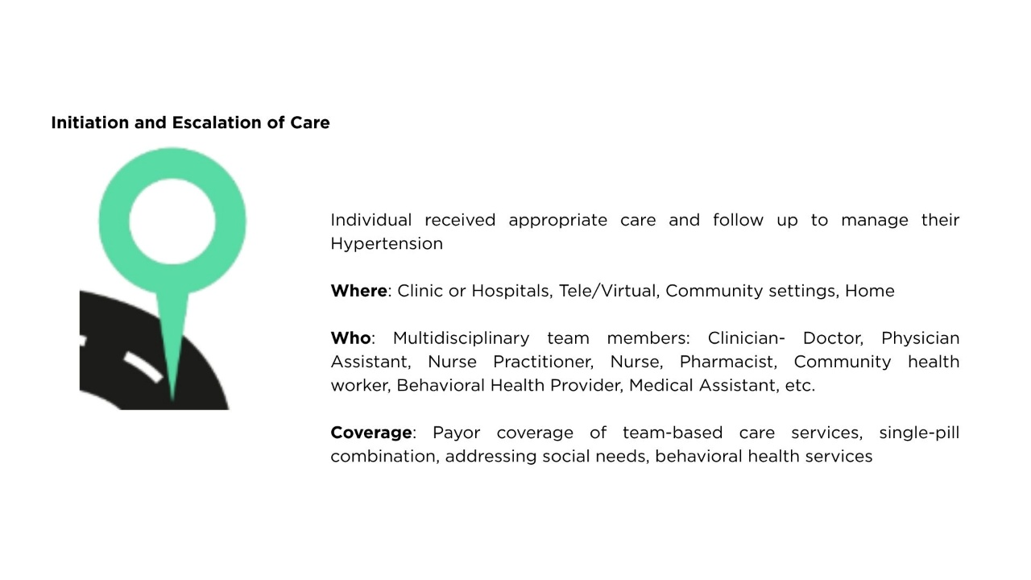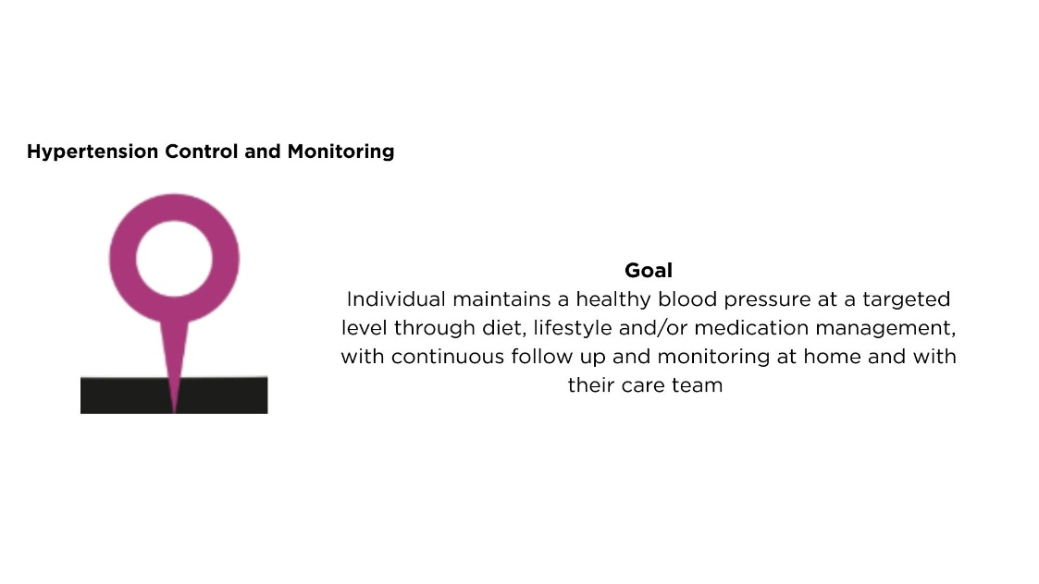

Stakeholder-Specific Guidelines

Primary Care Settings and Professionals
- Review Key Priorities in the Executive Summary

Screening & Diagnosis
- Screen BP in all adults at least annually per USPSTF guidelines using accurate methods. (see Target: BP)
  - Refer people with BP >130/80 for further primary care
  - For those with BP >120/80 provide blood pressure management education materials
  - Train staff in proper measurement techniques regularly
  - Partner with community organizations (e.g., faith-based, pharmacies) and employers to expand screening; consider mobile units if needed.
    - At screenings, offer immediate pathways to care.
- Annually screen for health-related social needs and establish protocols to address them, integrating findings into care plans. Follow FHCQ’s report on Social Need and Health Equity and other evidence-informed guidelines.
- Screen for behavioral health needs per current clinical recommendations using validated tools (e.g., PHQ-9, GAD-7)
- Encourage people with elevated blood pressure to use a validated home machine, maintain a BP log, and complete validation visit promptly.
  - Validation visit should include validating the machine and cuff size, reviewing technique and supplying a log if not already provided
  - Schedule a 2-week follow-up after validation to assess readings and plan next steps.

Individualized Blood Pressure Management
- Diagnose hypertension accurately per national guidelines (e.g., AHA/ACC), confirming with multiple and out-of-office readings.
- After diagnosis, create and document a patient-centered management plan to achieve healthy blood pressure:
  - Calculate cardiovascular risk using tools like PREVENT.
  - Collaboratively establish individual blood pressure goals and identify treatment approaches that reflect unique health circumstances, considering latest evidence-based hypertension guidelines (AHA/ACC, AAFP) and other health conditions. Use patient decision aids
  - Customize plans for preferences, culture, and language; involve interpreters as needed.
  - Monthly follow-ups until BP is controlled, escalating treatment if necessary.
  - Leverage payor resources (CVD prevention programs, care coordination, etc.).
  - Identify evidence-based, practical treatments that empower patients and support long-term success.
  - Promote self-management and self-efficacy through SMBP programs, education, and other techniques.
  - Involve multidisciplinary team members for holistic care (e.g., behavioral health, nutrition, community health worker, etc.).
- Align hypertension management policies with current guidelines; offer treatment by hypertension stage and risk factors, referencing 2025 AHA/ACC hypertension guidelines.
  - For those those with stage 1 hypertension and 10 year CVD risk <7.5%, generally begin with 3-6 month trial of lifestyle interventions before medication. Monthly follow-up is crucial.
  - After 3-6 months, engage in shared decision-making conversation about initiation of medication.
Table 1. CVD Risk Stages
BP/Stage HTN | 10 year CVD risk <7.5% | 10 year CVD risk >/= 7.5% | Living with CVD
Stage 1 | 3-6 month trial of lifestyle intervention, initiate medication if sustained hypertension; single first-line reasonable with dose titration and sequential addition of other agents as needed | Initiate medications; single first-line reasonable with dose titration and sequential addition of other agents as needed | Initiate medications; single first-line reasonable with dose titration and sequential addition of other agents as needed
Stage 2 | Initiate medications; single-pill combination recommended | Initiate medications; single-pill combination recommended | Initiate medications; single-pill combination recommended

- Nonpharmacological intervention
  - Assess available nutritional resources and tailor diet advice to what's feasible for each person. Recommend DASH diet with emphasis on fruits, vegetables, whole grains, low-fat dairy, and reduced sodium (<2,300 mg/day, ideally <1,500 mg/day). Use culturally adapted tools for guidance.
  - Set achievable physical activity targets, adjusting for personal circumstances; suggest 150+ minutes of aerobic exercise per week.
  - Discuss weight management in a non-stigmatizing, person-centered way, focusing on healthy behaviors rather than weight alone; prioritize sustainability.
  - Promote moderation or avoidance of alcohol and tobacco tailored to individual readiness and motivation. Provide cessation resources.
  - Encourage stress management and behavioral health care within overall lifestyle changes.
- Pharmacological intervention:
  - Recommend single-pill combination therapy for stage 2 hypertension when possible.
  - Prefer once-daily dosing if feasible.
  - Do not apply race-based medication guidelines
- Address needs of people with comorbidities (diabetes, kidney disease, overweight/obesity, cerebrovascular disease, etc.) and screen for secondary hypertension causes per latest guidelines (2025 AHA/ACC). See Appendix for further details
- Implement referral system or internal program for self-measured blood pressure monitoring (SMBP):
  - Provide validated BP machines and cuffs with inclusive sizing for immediate access (loaner or take-home options).
  - Create a system for recording home BP readings in the EHR.
  - Train staff in BP self-management (e.g., teach-back method).
- Distribute patient education materials on hypertension and ensure resources are accessible in appropriate languages and cultures.

Integrated Team-based Care
- Form a multidisciplinary care team for hypertension patients, following the structure below:
  - Use consistent team-based care strategies such as huddles and high-risk panel reviews
  - Regularly provide comprehensive services for those at risk or living with hypertension, including:
    - Behavioral health visits
    - Guideline-based medication management
    - Self-measured blood pressure (SMBP) programs and counseling
    - Education and lifestyle support for hypertension
    - Care for co-occurring conditions (e.g., kidney disease, diabetes)
    - Extra support for those with uncontrolled hypertension (intensive management, home/community visits)
  - Offer convenient and flexible care options:
    - Nontraditional visit types (virtual, phone, text, group, home)
    - Extended hours (early, late, weekends)
    - Visits with non-providers (pharmacists, nurses, community health workers, etc.)
- Utilize a population health approach for hypertension using event notifications, coordinated care, and a registry
- Delegate tasks like medication changes, education, and follow-up to non-provider team members. Use standing orders when within scope of practice.

Quality Improvement
- Join alternative payment models that support high-quality hypertension care, especially risk-adjusted primary care capitation.
- Use measures and metrics to monitor hypertension control
  - track hypertension prevalence stratify by demographics (race/ethnicity, language, location, social needs, disability).
    - Further break down racial/ethnic groups when possible (e.g., Chinese American, Japanese American, Korean American, Native Hawaiian, Pacific Islander).
  - Identify and reach out to undiagnosed patients using established clinical criteria (two readings >140/90mmHg.)
- Apply quality improvement strategies:
  - Use evidence-based treatment protocols.
  - Set appointment triggers for uncontrolled hypertension.
  - Integrate decision support into workflows.
  - Give providers feedback on their hypertension control performance.
- Participate in national quality improvement award programs (e.g., Target:BP Recognition Program)

Specialty Outpatient Clinics
- Review Key Priorities in the Executive Summary

Screening & Diagnosis
- Screen BP in all adults at least annually per USPSTF guidelines using accurate methods. (see Target: BP)
  - Refer people with BP >130/80 for further follow up with primary care
  - For those with BP >120/80 provide blood pressure management education materials
  - Train staff in proper measurement techniques regularly
- Annually screen for health-related social needs and establish protocols to address them, integrating findings into care plans. Follow FHCQ’s report on Social Need and Health Equity and other evidence-informed guidelines.

Hospitals
- Review Key Priorities in the Executive Summary

Screening & Diagnosis
- Screen BP in all adults at least annually per USPSTF guidelines using accurate methods. (see Target: BP)
  - Refer people with BP >130/80 for further follow up with primary care.
  - For those with BP >120/80 provide blood pressure management education materials
  - Train staff in proper measurement techniques regularly
  - Partner with community organizations (e.g., faith-based, pharmacies) and employers to expand screening; consider mobile units if needed.
    - At screenings, offer immediate pathways to care.
- Annually screen for health-related social needs and establish protocols to address them, integrating findings into care plans. Follow FHCQ’s report on Social Need and Health Equity and other evidence-informed guidelines.
- Encourage people with elevated blood pressure to use a validated home machine, maintain a BP log, and complete validation visit promptly

Individualized Blood Pressure Management
- Diagnose hypertension accurately per national guidelines (e.g., AHA/ACC), confirming with multiple and, if possible, out-of-office readings
- Align hypertension management policies with current guidelines; offer treatment by hypertension stage and risk factors, referencing 2025 AHA/ACC hypertension guidelines.
- Incorporate culturally- and linguistically appropriate services including interpreter access, low-literacy materials, and staff members that service to link individuals to resources that address social and structural barriers

Integrated Team-based Care
- Employ structured treatment algorithms to expedite initiation and intensification of therapy when indicated.
- For folks with a new diagnosis of hypertension, or with hypertension but without access to primary care, establish appointments with primary care within a week after discharge as possible to develop a person-centered management plan. Coordinate follow-up as able.

Quality Improvement
- Commit to equitable blood pressure prevention, detection and control for all patient populations served in a formal organizational equity strategy
- Monitor disparities in blood pressure control by stratifying performance metrics by individual-level variables (e.g., race/ethnicity, language, location, social needs, disability)

Health Plans
- Review Key Priorities in the Executive Summary

Screening & Diagnosis
- Encourage contracted providers to utilize AHA/ACC endorsed quality process measures for screening for high blood pressure
- Offer and publicize rewards for annual biometrics screening.

Individualized Blood Pressure Management
- Cover the following services/items to improve hypertension management and care per national guidelines, with minimal cost sharing/co-pay and prior authorization:
  - Validated home blood pressure monitors (preferably digital)
  - Screening/addresing health-related social needs
  - Monthly hypertension control visits
  - First line antihypertensive medications, including single-pill combinations
  - At least quarterly pharmacist-led medication management visits in year one, then as needed
  - Monthly medical nutrition therapy in year one, then as needed
  - Behavioral health counseling (individual and group). Consider health behavior assessment and intervention services (HBAI) at parity with psychotherapy (CPT CODES)
  - Self-measured blood pressure (SMBP) services, with validation visit
  - Non-visit-based care (e.g., portal, text)
- Consider additional care coordination services for members with uncontrolled hypertension
  - Enhanced care management for multiple chronic conditions
- Provide outreach and education to members with uncontrolled hypertension
  - Target those missing prescriptions
  - Adapt educational material for cultural/linguistic needs; ensure readability and accessibility.
- Adjust medication policy to reduce barriers to access (e.g., extend medication refills, mail order pharmacy)

Integrated Team-based Care
- Provide coverage for multidisciplinary, team-based hypertension care along the spectrum of fee-for-service to population based payments, including advance models that incorporate risk adjustment.
  - Incorporate value-based payment mechanisms that reward teams for reaching blood pressure control targets in population subgroups with greatest disparities (e.g., race/ethnicity, language, location, social needs, disability, etc.)
  - Incorporate policies that allow for expansion of team-based care (e.g., collaborative practice agreements with pharmacists)
- Leverage the Health Care Authority’s Medicaid 1115 waiver and Primary Care Transformation model to move toward population-based payment for hypertension management.
  - Leverage health-related services payments to cover additional services for members with hypertension

Quality Improvement & Data Insights
- Identify groups with disparities in blood pressure screening and control by demographic and geographic factors (e.g., race/ethnicity, language, location, social needs, disability)
- Target outreach to member groups experiencing disparities, tailoring efforts to specific community barriers; collaborate with community-based organizations where possible.
- Incentivize providers to reduce disparities in hypertension control
  - Tie rewards to measurable improvements identified disparities
  - As able, disaggregate racial and ethnic subgroups further to better target improvement interventions (e.g., Korean Americans, Japanese Americans, Chinese Americans, etc. instead of Asian American)
- Maintain certifications that require excellence in addressing health-related social needs (e.g., NCQA)
- Require health equity and cultural sensitivity training for all relevant staff
- Strengthen health and community information exchange across plans and providers using interoperability standards. (e.g., FHIR, HL7)
- Engage in initiatives to improve health information exchange and community information exchange between different plans and provider systems using interoperability standards (e.g., FHIR, HL7)

Employers and Health Care Purchasers
- Review Key Priorities in the Executive Summary

Screening & Diagnosis
- Host or partner with clinics to provide on-site preventive health screenings including hypertension screening. Any event screening for hypertension should have a clearly defined protocol for those needing emergency medical attention and for connecting employees with hypertension to continuing healthcare.
  - Offer screening at different times and days and in accessible locations
  - Consider incentives and/or other support (e.g., childcare) to facilitate screening
  - Cover screening at no cost-sharing to employees
- Provide or incentivize biometric screening including blood pressure, and consider implementing multicomponent of workplace wellness programs.
  - Include components such as physical activity and nutrition programs, care management for those with diagnosed chronic conditions, and behavioral health visits
- Raise awareness about annual preventive screenings, including blood pressure, through employee facing campaigns, time off to complete screenings and rewards for screening

Individualized Blood Pressure Management
- Offer opportunities (e.g., roundtables, focus groups) for employee feedback on benefit design. Use employee feedback to co-design health benefits, programs and policies
- Require health benefit vendors cover and provide home blood pressure monitors, ideally with ability to transmit blood pressure readings digitally, and promote how employees can access this benefit (e.g., prescription, FSA, HSA, etc.)
- Adopt policies and resources that reduce employee risk of hypertension (e.g., smoke-free campus, smoking cessation programs, space for physical activity, healthy food options, etc.) and consider encouraging network providers in certification for lifestyle medicine
- Consider providing as able health promotion events to support employee wellness led by licensed/certified clinicians (e.g., mindfulness exercises, physical activity programs, nutrition seminars/programs, etc.)
- Identify health-related social needs affecting employees and dependents without compromising personal data or privacy and provide confidential assistance for identified social needs.
- Communicate available resources (health plan benefits, wellness programs, etc.) through means that meet employee cultural and linguistic needs (e.g., materials translated to Spanish, Korean, etc. and culturally adapted), and in ways that are easy to understand and access
- Ensure benefit vendor includes policies that reduce barriers to hypertension medication access (e.g., minimal cost sharing, 90 day supply, mail order available, minimized prior authorization, least restrictive tier structure for evidence-based antihypertensive medications, etc.)

Integrated Team-based Care
- Require health benefit vendors to incorporate coverage for community health workers, mobile billable services, and other services that promote team-based care
- Provide access to mental health and substance use care through vendors at parity to physical health care
- Require health benefit coverage of telehealth/virtual appointments at parity to physical visits
- Consider incenting providers to pursue educational opportunities and certification of lifestyle medication

Quality Improvement & Data Insights
- Identify key metrics related to hypertension control equity for evaluation of contracted carriers. Require vendors to collect and share hypertension prevalence and control rates by subgroups including but not limited race/ethnicity, language, location, social needs, disability, etc. See Evaluation Framework for further details.
  - Hypertension prevalence and incidence
  - Hypertension control
  - Overweight and obesity prevalence
  - Incidence rates and costs for cerebrovascular and cardiovascular events
  - Overall trends in direct costs for general population and population with hypertension
- Tie vendor performance guarantees to closing documented gaps in hypertension control across population subgroups
- Target interventions to support employee groups with disparities in hypertension control
- Set performance guarantees with contracted vendors that specifically require improvement in controlling blood pressure using HEDIS quality measure, including stratified by relevant factors (e.g., race/ethnicity, language, location, social needs, disability)
- Utilize evidence-based tools to estimate return on investment of providing care chronic conditions (e.g., international benefits institute)

State Agencies

Washington Health Care Authority
- Review Key Priorities in the Executive Summary

Individualized Blood Pressure Management
- Include single pill combination medication single preferred drug list when possible.
- Facilitate provision of primary care services in nontraditional settings (e.g., mobile vans, local businesses)

Integrated Team-based Care
- Continue to incentivize integration of community health workers across clinical settings, especially in primary care
- Facilitate implementation of team-based models of care across primary care setting

Quality Improvement & Data Insights
- Promote value-based payment arrangements that incorporate blood pressure control stratified by race and ethnicity, at a minimum. As possible, incorporate further dimensions of stratification such as language, income, disability status to further target performance improvement.
- Identify populations with disparities in BP screening and blood pressure control between sub-populations based on claims data and other relevant information and create publicly available data visualizations to inform (e.g., GIS maps)
- Consider aggregating HEDIS CBP measure by geographic location (e.g., RURA) to identify disparities in rural and urban populations

Washington Department of Health and Local Health Jurisdictions
- Review Key Priorities in the Executive Summary

Screening & Diagnosis
- Coordinate and/or host community-based blood pressure screening and education events with established protocols for follow up and connection to care
  - Refer people with BP >130/80 for further primary care
  - For those with BP >120/80 provide blood pressure management education materials
  - Train staff in proper measurement techniques regularly
  - Partner with community organizations (e.g., faith-based, pharmacies) and employers to expand screening; consider mobile units if needed.
  - At screenings, offer immediate pathways to care
- Consider developing a “know your numbers” card modeled off COVID19 vaccination card for individuals to track their own blood pressure. Distribute to screening events and primary care.

Individualized Blood Pressure Management
- Convene partners to develop health education and campaigns promoting individual blood pressure management across communities
- Incorporate community member voice into design and implementation of any community-based work
- Promote programs to access affordable healthy foods, especially in geographic areas with historically low access to grocery stores and/or low income
- Promote and advocate for physical spaces that offer safe space for activity across neighborhoods
- Invest in projects that focus on expanding rural access to care for chronic conditions (telehealth/virtual care options, mobile vans, transportation benefits)

Integrated Team-Based Care
- Support continued integration of community health workers into clinical settings

Quality Improvement
- DOH: Develop a statewide population health hypertension control strategy aligned with national frameworks (Million Hearts, Healthy People 2030) and integrated with state plans to address chronic conditions
- Set and communicate public health goals for blood pressure control rates, disaggregated by race/ethnicity, language, location, social needs, disability, and other relevant population sub-groups
- Maintain and publish data dashboards on hypertension prevalence, control and mortality stratified by race, ethnicity, age, gender, income, insurance status, geography and/or other relevant variables
  - Use data to identify sub-populations experiencing disparities in hypertension
- Disseminate quality improvement tools for BP control to delivery systems across Washington
- Advocate for policies that reduce impact discrimination, especially racial and ethnic discrimination

Community Pharmacies
- Review Key Priorities in the Executive Summary

Screening & Diagnosis
- Train pharmacy employees and other relevant staff on how to measure blood pressure accurately and appropriate follow up protocols at regular intervals
- Label blood pressure devices for purchase whether or not they are validated, including kiosks (U.S. Blood Pressure Validated Device Listing)
- Provide environment to support accurate BP screening (e.g., chair in quiet environment, dark environment)
- Communicate new elevated blood pressure to patient’s primary care provider with permission

Individualized Blood Pressure Management
- Consider establishing self-measured blood pressure (SMBP) monitoring program with collaborative practice agreements with delivery systems

Integrated Team-based Care
- Engage in collaborative practice agreements with local delivery systems to co-manage people with hypertension

Dental Clinics/Dentists
- Review Key Priorities in the Executive Summary

Screening & Diagnosis
- Screen every patient’s blood pressure at intake, at least annually, and before any treatment, especially requiring certain medications (e.g., epinephrine) using validated blood pressure measuring device. Document in the dental record.
  - Refer people with BP >130/80 for further primary care
  - For those with BP >120/80 provide blood pressure management education materials
  - Train staff in proper measurement techniques regularly (see Target: BP)
Blood Pressure (mmHg) | Elective Dental Care | Emergency Dental Care | Referral to primary care
<160/100 | No modification |  | - BP > 130/80mmHg: if patient not previously diagnosed with hypertension, refer to primary care  - BP > 140/90mmHg, regardless of hypertension diagnosis, refer to primary care for further evaluation
>160/100* | Repeat measurement  - If lowered or within written guidance from a provider, proceed  - If confirmed, no elective dental treatment and the patient should seek consultation with a physician | Repeat measurement  - If lowered or within written guidance from a physician, proceed  - If confirmed systolic pressure 160–180 mmHg and/or diastolic pressure 100–109 mmHg where dental symptoms and pain contribute to hypertension, initiate emergency care with blood pressure monitoring every 10 to 15 minutes during procedure; consider anxiety reduction techniques  - If confirmed systolic pressure >180 mmHg and/or diastolic pressure >109 mmHg, seek consultation with a physician before proceeding | Repeat measurement  - If lowered or within written guidance from physician, do not refer  - If confirmed systolic >/= 180/120 without evidence of target organ damage, refer to established PCP or refer to establish care  - If confirmed BP >/= 180/120 with evidence of target organ damage, refer to emergency care for hypertensive crisis

- Referrals to primary care providers should include the following information:

- Establish and maintain a protocol for dangerously elevated blood pressure that prioritizes immediate connection to emergency care (e.g., calling 911, referring patient to the emergency department) for those with signs of target organ damage
- Use validated blood pressure devices and regularly calibrate them

Individualized Blood Pressure Management
- Maintain a complete medical history including medications for all patients, and for patients with hypertension. Review Appendix. for detailed information on medications
- Update electronic dental record with most current lab values, medications and vital signs
  - Monitor for adverse effects of anti-hypertensive medications, like dry mouth (xerostomia), oral lichenoid reaction, dysgeusia, gingival hyperplasia
- For patients with hypertension undergoing more complicated stress-inducing dental procedures such as long-duration restorative procedures, oral/periodontal treatments and the placement of dental implants, intermittent monitoring of blood pressure is warranted
- In general, keep dose of vasoconstrictors below 0.04mg per appointment for those with hypertension
- Follow American Dental Association’s recommendations on providing dental care to patients with hypertension

Integrated team-based care
- Establish a standardized referral process to primary care clinics in your area.
- Consult with patient’s prescribing provider (e.g., PCP, cardiologist) for any adverse effects of antihypertensive medications that might warrant adjustment in treatment plan

Evidence Review
Maintaining healthy blood pressure is part of routine health maintenance and chronic disease prevention. Hypertension (HTN) impacts about half of American adults; many communities experience a disproportionate burden of uncontrolled hypertension including many minoritized racial and ethnic groups, those with lower levels of education or income, those living in more rural settings and with concerns in other health-related social needs, such as food or housing insecurity.,, Below is a table displaying national hypertension prevalence and control across communities based on various separate and intersecting identities.
Population | Hypertension Prevalence | Hypertension Control
Race and/or Ethnicity
Non-Hispanic Black Americans | 45.3% | 39.2%
Hispanic Americans | 31.6% | 40.0%
Asian Americans | 31.8% | 37.8%
White Americans | 31.4% | 49.1%
Other Americans | 36.6% | 47.2%
Disability Status
Living without disability | 43.0% | 13.4%
Living with disability | 50.0% | 19.3%
Insurance Coverage
Yes | 37.91% | 40.49%
No | 51.51% | 22.2%
Education
Less than high school | 54.03% | 24.08%
High school of GED | 52.04% | 37.88%
Some college | 53.87% | 41.36%
College and above | 41.61% | 46.4%
Geographic location
Population | Hypertension Prevalence | Using Antihypertensive Medications
Large central metro (city) | 28.5% | 56.2%
Large fringe metro (suburb) | 28.7% | 59.7%
Medium metro | 30.4% | 60.8%
Small metro | 31.4% | 60.2%
Micropolitan | 32.6% | 62.6%
Noncore (rural) | 34.1% | 64.8%

Blood Pressure Control in Context
Despite clear guidelines for hypertension treatment, control remains challenging for many people. Folks with hypertension face many barriers to accessing care, engaging in care and achieving sustained blood pressure control.
- Racism and Discrimination: The American Heart Association identifies racism and discrimination as chronic psychological stress from racism and discrimination has been linked to hypertension onset and control
- Health-Related Social Needs: Controlling blood pressure requires significant time and attention on behalf of patients; initial management should include interventions such as dietary changes, increased exercise, weight loss, stress management and more. These strategies are difficult to sustain, even for folks with more economic and social resources. Challenges are often greater for historically marginalized groups – for example, those without access to neighborhood resources like a safe place to exercise, or places to buy healthy food (e.g., food deserts) can experience worsening hypertension disparities. Health literacy can be a barrier to blood pressure control – hypertension often needs lifelong management and/or treatment but is often asymptomatic. Culturally and linguistically congruent and adequate information and education around hypertension can often be lacking, leading to worse communication for patients who speak a language other than English; when providers and patients speak the same language, there are improvements in cardiovascular risk. Other health-related social needs including transportation, housing, income and education influence access to and use of healthcare. For example, housing instability can chronically elevate stress hormones and blood pressure. Those living with disabilities also experience a higher prevalence of hypertension, even after controlling for other factors such as income.
- Healthcare System and Structural Barriers: Many structural barriers exist to improving hypertension control in Washington state. Those without access to a consistent source of care or access to health insurance are less likely to have their hypertension under control. Geographic proximity to care can influence access as well – rural areas experience provider shortages more frequently, and may have limited options available for in person visits. Fragmented systems of care (e.g., seeing multiple providers without coordination) also contributes to gaps in follow-up and confusing navigation issues for patients and families.
- Clinical Barriers: One someone is “in the door” of healthcare, they can experience gaps in clinical management as well. Clinical inertia, or providers failing to intensify treatment when blood pressure is uncontrolled, can result in gaps in in appropriate care, and worsening disparities. For example, there is some evidence to suggest that clinicians do not intensify treatment for Black patients’ blood pressure as often compared to White patients. Use of evidence-based treatment protocols or algorithmic care can standardize approaches to high-quality treatment. Another barrier that can impact effective identification and treatment of hypertension is accurate measurement of blood pressure. Inaccurate measurement for those using unvalidated cuffs or wrong size cuffs can influence treatment decisions incongruent with the patient’s actual blood pressure. Finally, implicit bias and cultural sensitivity of the healthcare team impacts the patient-provider relationship, leading to decreased trust, a lack of safe spaces for patients and communication breakdowns that result in delayed or inadequate care.
- Mental Health and Substance Use: Depression is associated with increased cardiovascular risk, and has been shown in some studies to be correlated with uncontrolled hypertension and blood pressure variability. Those with mental health concerns such as schizophrenia or bipolar disorder have increased cardiovascular risk, and often do not receive appropriate cardiovascular care in part due to stigma and discrimination surrounding mental illness, and therefore hypertension and other conditions such as diabetes go undiagnosed and undertreated.The 2025 American Heart Association Hypertension Guidelines recommend abstaining from alcohol if possible, or at least minimizing use as much as possible in those with hypertension, Alcohol use and smoking cessation has long been associated with better blood pressure control and reduction of cardiovascular risk. Those with substance use disorders, such as opioid use disorder or stimulant use, are often affected through discrimination and bias, leading to fragmented preventive care, and underdiagnosed and undertreated hypertension.
Patient-centered care for people with hypertension means holistically identifying and addressing the needs, concerns and preferences of each person. Teams caring for patients need to understand the range of factors that can impact blood pressure, tailor care plan strategies to address the identified barriers most significantly impacting the person’s life, communicate the clear evidence-based strategies that are likely to reduce blood pressure or prevent elevated blood pressure, and come to a shared care plan that prioritizes patients needs, is feasible, and holds members of the care team accountable for monitoring and adjusting course in collaboration with the individual and their support system.

Towards Universal Blood Pressure Screening
About 2 in every 5 people with hypertension in the United States are unaware they have it. Certain groups are less likely to know they have hypertension, including those 18-39 years old, men, certain Hispanic American populations, and Asian American populations.
Multilevel strategies are needed to reach communities with more folks with undiagnosed hypertension. The workgroup endorses the following priorities to identify people with undiagnosed hypertension:
- Abundant opportunities for blood pressure screening in places where community members already gather (e.g., work, faith-based organizations, community centers, barbershops, community pharmacies) or at existing touch-points within the health care ecosystem (e.g., emergency rooms, dental clinics, urgent care).
- Screening events should ALWAYS be accompanied by a set protocol with clear responsibility for making connection to care (e.g., follow up phone call, scheduling a new appointment, etc.) that is based on standardized criteria for referral (e.g., refer to emergency room for hypertensive crisis (SBP>180 with target organ damage), refer to primary care for SBP >/=130))
- Wherever possible, provide direct access to care in community-based setting (e.g., pharmacy visits housed in a community organization or business, or provided through virtual/digital means onsite)
- Folks needing evaluation of blood pressure >130/80 should be referred to primary care and generally with use of out of office monitoring techniques (HBPM, ABPM)’
- Education/educational materials provided for folks >120/80 in language and literacy level congruent with community needs
- Ideally, engage in further supportive activities with folks with elevated blood pressure or hypertension, including reviewing the validated BP machine list, discussing the importance of obtaining a validated machine, and teaching proper technique for measuring blood pressure at home.
Health care delivery systems should use the patient data they already collect to identify those with undiagnosed hypertension already in their systems. Clear criteria for potentially undiagnosed hypertension can indicate need for further confirmatory testing, using either home blood pressure monitoring (HBPM) or ambulatory blood pressure monitoring (ABPM). One example of clinics have used EHR data to identify those that might have undiagnosed hypertension. Those identified with potentially undiagnosed hypertension should be scheduled for follow-up and further evaluation by the care team.
Example Undiagnosed Hypertension Stage 1 Criteria: Patients 18-85 years old without a diagnosis of hypertension (documented as ICD-10 code) who have SBP or DBP measurements consistent with definition of stage 1 hypertension at two separate medical visits, including most recent visit, during the past 12 months. Exclusions: pregnancy, ESRD
Example Undiagnosed Hypertension Stage 2 Criteria: Patients 18-85 years old without a diagnosis of hypertension (documented as ICD-10 code) who SBP or DBP measurements consistent with stage 2 hypertension at any visit within past 12 months. Exclusions: pregnancy, ESRD
Reducing variation in undiagnosed hypertension rates between populations is a top priority. Studies show that adults from marginalized racial and ethnic groups are more likely than Non-Hispanic White adults to have undiagnosed or uncontrolled hypertension, contributing to higher risks of stroke, heart failure, and kidney disease. Structural barriers—such as lack of health insurance, limited access to preventive services, and lack of culturally safe health system environments—contribute to these disparities. Additionally, language barriers, transportation challenges, and competing socioeconomic priorities often delay routine screening, leaving hypertension undetected until advanced complications arise.
To adequately address blood pressure control equity, health systems must meet patients where they are in the community. Programs that bring blood pressure screening to trusted community venues—such as churches, barbershops, and cultural centers—have been shown to identify previously undiagnosed hypertension at much higher rates than traditional clinic-based approaches. For example, faith-based initiatives and barber-led interventions in Black communities not only improve screening reach but also facilitate linkage to care and long-term blood pressure control. By bringing team members that are able to directly link patients to care into the community, systems can avoid breakdown in communication and additional barriers for patients to overcome in scheduling appointments and starting their journey to better blood pressure management. Similarly, community health worker (CHW)-led programs in Hispanic populations and others have demonstrated success in both identifying undiagnosed hypertension and supporting behavior change, medication adherence, and follow-up with primary care providers.
Wayne Mobile Medical Unit: mobile van units staffed by registered nurses, medical/research assistants, community health workers and patient/family advocates, with physician supervision, to provide free health screenings and preventive services to patients. Services include:
- Vaccinations
- COVID-PCR testing
- Blood work screening and Blood pressure screening
- HIV screening
- PC referrals, specialty referrals, and patient education
See more here.
Mobile care delivery units are also an effective strategy for expanding preventive care access in hard-to-reach areas. Units bring essential services including blood pressure screening directly to neighborhoods, organizations and businesses to meet people where they are. One example of a successful mobile unit model partnership between delivery systems and employers is the Wayne Mobile Medical Unit in Detroit, where a mobile van will visit employers on site and other areas in neighborhoods with high burden of chronic disease.
Community-based screening events naturally complement education to empower individuals to be aware of and act to improve their own health. The ”Know Your Numbers” campaign by the American Heart Association encourages individuals to take an active role in their health by regularly checking their blood pressure, becoming familiar with their personal readings, and checking and understanding other relevant biometrics. People are taught what their blood pressure numbers mean, how to interpret results, and when to seek further evaluation or care. In addition to screenings, the campaign emphasizes the importance of tracking blood pressure over time, utilizing tools like home blood pressure monitors (HBPM) and ambulatory blood pressure monitoring (ABPM) to provide more accurate and comprehensive assessments.
The workgroup endorses an approach framed by the socioecological model the encourages all actors in the system to incent, prioritize and act to achieve universal hypertension screening for all adult Washingtonians. See the following diagram: 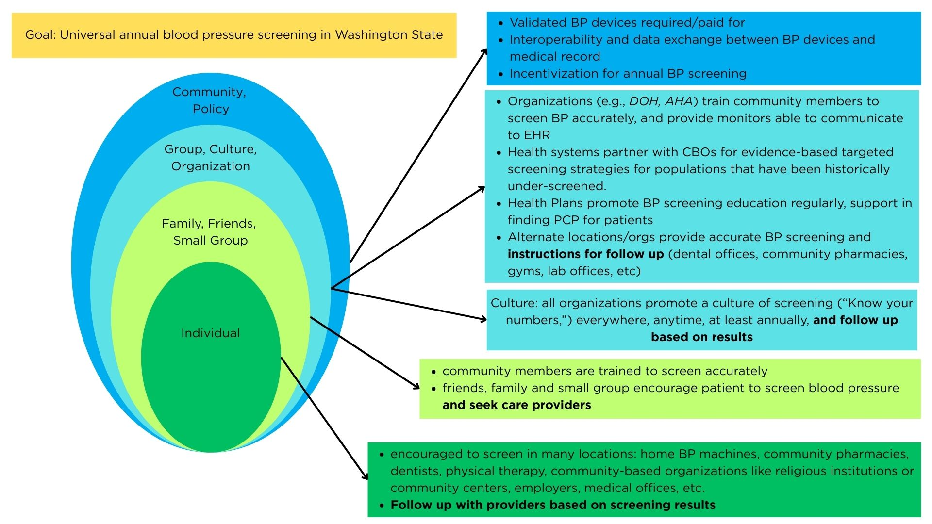

Blood Pressure Self-Management
People with hypertension should be empowered to understand and manage health at home. Multidisciplinary teams can be more effective in their care by helping individuals take control of their own blood pressure management at home and in conjunction with the care teams guidance. Self-Measured Blood Pressure (SMBP) monitoring programs are structured programs that support people In tracking and managing their blood pressure at home. Delivery systems with in house SMBP programs utilize patient-generated data to allow more granular management from care teams. While a self-monitoring program can exist in the community setting, such as the YMCA, health delivery systems can leverage the data generated to improve their monitoring. The following diagram is from the National Association of Community Health Centers Self-measured Blood Pressure Monitoring Implementation Guide to support the community health centers in starting their own SMBP. Below is a general graphic depicting where SMBP exists in the process of identification and control of hypertension.
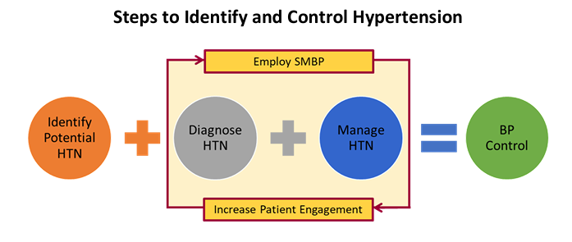

Team-Based Care
Multidisciplinary team-based care is critical to addressing structural and individual barriers to hypertension control and is endorsed by the AHA in their updated 2025 hypertension guidelines. Teams may include a variety of health professionals including physicians, nurse practitioners, physician associates/assistants, pharmacists, dieticians, community health workers, nurses, behavioral health professionals, and others. When team members possess congruent identities with the patients they serve (e.g., shared language, shared cultural background), team-based care is likely to decrease variation in quality of care between groups; It is also cost-effective, costing less than $50,000 per quality-adjusted life year. Team-based care improves blood pressure control by providing more opportunities for regular follow up and communication, facilitating self-management at home, and allows for more iterative medication management with care team members (e.g., pharmacist) that are not the physician or advanced practice provider, allowing teams to work at the top of their scope of practice.
Multidisciplinary team-based care has been shown to improve hypertension-related patient outcomes. comparing implementation strategies for blood pressure control in patients with hypertension, team-based care with medication titration from a nonphysician is more effective at reducing systolic blood pressure than physician titration or multilevel strategies without team-based care. When looking specifically at team-based care as a strategy to improve blood pressure control for people with many barriers to care, community health workers and pharmacists are effective when integrated in care workflows.
The AHA and other national guidelines endorse the use of team-based care to support patients with hypertension. The following is a description of responsibilities and roles of the team drawn from the AHA/ACA 2025 guidelines.
This table was adapted from the AHA/ACA 2025 High Blood Pressure Guidelines Supplemental Material on team-based care. The team members indicated by an * are adopted from the AHA guidelines.
Hypertension Team Responsibilities
- Communication, shared decision-making, and care coordination among various clinical team members, the patient, and patient caregivers
- Effective use of evidence-based diagnosis and management guidelines
- Regular, structured follow-up mechanisms and reminder systems to monitor patient progress
- Medication adherence support and patient education about hypertension medication
- Medication initiation, addition, and titration using evidence-based treatment algorithms
- Use of evidence-based tools and resources designed to maximize self-management (including health behavior change, lifestyle modification, etc.)
Individual Hypertension Team Members | Roles (examples)
Patient & Caregivers | Driver and decision-maker of care
Medical Assistants | Accurate screening, prepare patients for appointments and follow-up, and facilitate coordinated management
Primary Care Physician, Physician Assistant, Advanced Practice Nurse* | Routine and complex hypertension care, managing primary care issues
Cardiologist* | Routine and complex hypertension care, especially for patients with  cardiac disease or high risk for major cardiovascular events.
Nephrologist, Endocrinologist, Hypertension Specialist* | Management of complex hypertension care, especially due to secondary causes, and/or resistant hypertension.
Nurse (including in-office, home care, internal and external population health personnel)* | Accurate assessment of BP, medication reconciliation, patient education, self-management, lifestyle modification and adherence.
Clinical Pharmacist* | Comprehensive medication management, which involves identification and documentation of medication-related problems, initiating, modifying, and discontinuing medication to address identified problems, and educating patients on their medication regimen.
Dietitian* | Ongoing patient-centered counseling to assess dietary habits and preferences, set and monitor goals for healthy lifestyle
Social Worker* | Assess for psychosocial, cultural and financial barriers, find solutions to overcome these barriers.
Community Health Providers* | Assess and address social determinants of health and identify and promote acceptable community-based resources to overcome these barriers. Provide health education and advocacy
Behavioral Health Providers | Address behavioral health, stress, and lifestyle factors; support adoption of sustainable habits.

In addition to the responsibilities outlined by the 2025 AHA report, the workgroup developed minimal team functions outlined in the Delivery System – Primary Care section of our report and guidelines. These team functions can be tailored based on particular needs of patients and their support system, but all should be available as needed.

Team-Based Care Case Vignettes
Team-based care can be employed a number of different ways based on system capacity and team needs. The following are few examples of team-based care from the Washington State community:
Community Health Workers: Community health workers (CHWs) play a vital role in team-based care for hypertension by serving as trusted connectors between patients and the healthcare system. They help identify and address barriers to blood pressure control—such as medication adherence, access to healthy foods, transportation, or stress—through home visits and personalized support. CHWs provide and reinforce health education, promote self-monitoring of blood pressure, and link patients to community and social resources. They also communicate regularly with other care team members to share updates and coordinate care plans. CHWs can operate within a primary care team to improve care for groups generally otherwise underserved by the healthcare system. Community health workers often have linkages to the community and/or come from the community they serve which is critical to trust-building and culturally tailored care.

Embedded Pharmacist Clinic: Delivery systems can utilize pharmacists to expand access to care for chronic conditions and intervene early to reduce blood pressure. Delivery systems across Washington incorporate teams of pharmacists embedded in outpatient clinics that receive referrals for chronic condition management. Outpatient clinics can protocolize a referral pathway for individuals with hypertension to be referred to pharmacist support within 2 weeks for education and monitoring. Depending on individual patient needs, pharmacists will promote self-monitoring and lifestyle management to improve self-efficacy at home, and necessary escalation of care. Pharmacists manage medication titration, monitor labs, nutritional support, and communicating with providers. Generally, these teams have longer appointment times than providers and therefore can spend longer durations of dedicated time to discussing hypertension with their patients and can see them more frequently which supports getting to their hypertension goals faster. They also address ASCVD risk factors and management of other conditions (e.g., cholesterol, diabetes, weight loss) that impact whole-person health.

Access to Validated Blood Pressure Cuffs
Integrated Behavioral Health Providers: Behavioral health providers are key members of team-based care for hypertension, addressing the emotional, psychological, and behavioral factors that influence blood pressure control. They help people manage stress, treat mental health and substance use conditions, and other behavioral barriers that can interfere with blood pressure control and general well-being. Behavioral health providers integrated within primary care collaborate closely with other care team members to integrate mental and physical health goals. Through a variety of interventions (e.g., motivational interviewing, cognitive-behavioral strategies, and values clarification) they can support people in investing in their health, making sustainable behavior changes, increasing treatment adherence, and growing skills for managing stressful life circumstances that promote physical and mental wellness. Their involvement enhances overall well-being, improves self-management, and contributes to better long-term hypertension outcomes.
A significant barrier to self-measured blood pressure control is access to a validated blood pressure control machine. In Washington state, there are several ways to access validated blood pressure machines. The workgroup endorses that whenever possible machines should be covered without out of pocket cost to the patient and made easily accessible (e.g., provided while in clinic with a clinician)
- Payors: payors cover blood pressure machines as durable medical equipment (DME), with some allowing dispensing at pharmacies without required prior authorization (e.g., HCA Medicaid billing code for automatic BP monitors - A4670). These cuffs are limited to 1 per person every 3 years.
- Libraries: In the Libraries with Heart initiative, a partnership between libraries in Southwest Washington and the Puget Sound American Heart Association, patrons can check out home BP for a 3-week loan. The kits include an American Heart Association validated blood pressure device and cuff, an instruction booklet which outlines how to properly take blood pressure readings at home, information on what readings mean and steps individuals can take to move their blood pressure numbers into a healthier range.
- Public Health Department: Tacoma-Pierce county’s Check. Change. Control. Program offers a free validated blood pressure cuff to pregnant individuals to support self-measurement and monitoring.
- Grant-funded: Family Health Centers in Okanogan Washington applied for grant funding to support their self-measured blood pressure monitoring program, allowing them to buy validated blood pressure machines to provide them up front.

Health Information Exchange (HIE)
As the majority of health systems move to use of electronic health records (EHRs), sharing health information digitally in a secure manner can promote better patient care through standardizing collection of important information (e.g., demographics, diagnosis), facilitate clinician decision support services, and improve coordination of care. National organizations have standardized data elements for collection and exchange by health IT, developed common formats and interfaces, and established a framework for exchange of data between qualified health information networks (QHIN). EHR interoperability has been found to improve medication safety, reduce patient safety events, and save money. HIE interventions have resulted in reduction of 30-day all-cause readmission for patients with acute myocardial infarction., Washington state has invested in developing a state-based health information exchange to support collaboration across sectors. The Transformational Repository and Analytics eXchange (TRAX) program is a Washington Department of Health and Foundation for Health Care Quality-led project to support chronic disease surveillance using a collaboratively governed shared platform that leverages FHIR standards and abstracted clinical data.
Hypertension control (HEDIS CBP) is one of three pilot measures defined and captured by TRAX, along with measures for diabetes and depression screening and follow-up.
The TRAX governance team has identified four, Trusted Exchange Framework and Common Agreement (TEFCA) aligned, use cases that the data can be used for. Care coordination, case management, and quality improvement activities are supported by all four of the use cases. These include: public health (electronic lab reporting, immunization reporting, syndromic surveillance), Medicaid data exchange (care coordination, case management and quality improvement), cross-sector data integration (HRSN screening, electronic referral networks, BH information exchange, and quality improvement); value based payment and care models (care coordination, quality measurements, analytics and benchmarking)
The workgroup endorses engagement in electronic data sharing for the purposes outlined above, and participation in governance activities for TRAX or similar programs. For more information on TRAX, contact Karie Nicholas (knicholas@qualityhealth.org), Measurement and Evaluation Manager, Foundation for Health Care Quality, and Chris Baumgartner, Deputy Chief Informatics Officer, Washington State Department of Health (Chris.Baumgartner@DOH.WA.GOV).

Alternative Payment Mechanisms to Support Whole-Person Hypertension Care
Traditional fee-for-service models often incentivize volume rather than value, resulting in fragmented care and suboptimal outcomes. Alternative payment models (APMs) aim to align payment with quality, efficiency and patient-centered outcomes. Goals of APMs in aimed at hypertension care include:
- Incentivizing blood pressure control and cardiovascular risk reduction
- Supporting team-based, coordinated care
- Reduce avoidable hospitalizations and emergency visits related to hypertension complications
- Encourage population health management, including prevention for patients at higher risk
- Identify and address nonmedical drivers of health that affect hypertension risk and control
Integrated health information technology platforms to enable collection of data is critical to facilitating alternative payment models, especially for members with chronic conditions that may have multiple providers involved in their care team. However, the types of data collected and made accessible within this framework should be specified, including but not limited to patient experience data, quality metrics, and cost information. Trust and transparency as to the mechanisms of claims analysis and use of the data need to be present to facilitate a successful alternative payment model. Clearly defined outcome measures and metrics, benchmarks, incentives and regular evaluation are important to facilitate success. Payors and delivery systems need to foster trust and open communication to generate shared goals for these kinds of payment models.

Measurement
The report overall aim is to increase blood pressure control, and reduce variation control based on race, ethnicity and language. The Washington State Common Measure Set includes the NCQA HEDIS measure Controlling High Blood Pressure (CBP) which is stratified by race and ethnicity. The current CBP measure is included in value-based contracting and is defined as:
- Percentage of patients 18-85 years of age who had a diagnosis of hypertension (HTN) and whose blood pressure (BP) was adequately controlled (<140/90) during the measurement year. Race/ethnicity stratification.
The updated 2025 AHA hypertension guidelines classify stages of hypertension as Stage 1 (>130/80) and Stage 2 (>140/90). The NCQA proposed a new electronic clinical data system measure - Blood Pressure Control for Patients with Hypertension measure (BPC-E). This proposed measure would include the following updates:
- Electronic reporting method (ECDS)
- Expand numerator to allow for two BP levels of control (<140/90) and (<130/80)
- Expanded denominator to allow for pharmacy diagnosis
Washington Health Care Authority should support electronic reporting when possible and consider aligning nonelectronic reported measures of blood pressure control with these expanded criteria. The workgroup also endorses process measures and evaluation of equity should be evaluated to understand progress toward blood pressure control. These include:
- Blood Pressure Screening: Percentage of patient visits for patients aged 18 years and older seen during the measurement period who were screened for high blood pressure AND recommended a follow up plan in documented as indicated if blood pressure was elevated or hypertensive according to most updated AHA Hypertension guidelines
- Blood Pressure Control by Geographic Region: Aggregated HEDIS CBP stratified by geographic location (e.g., Rural-Urban Commuting Area Codes) to identify areas of greatest hypertension burden
For detailed information on evaluation of the implementation of report and guidelines, visit our Blood Pressure Control Evaluation Framework.

Washington State Initiatives

Washington State Department of Health – Heart Disease, Stroke & Diabetes Prevention Unit
This state-level public health program promotes evidence-based strategies to reduce hypertension and cardiovascular disease. Their initiatives include increasing access to active living, improving care coordination, promoting healthy foods, and supporting systems-level interventions—including community health worker engagement and provider training.
Meanwhile, the Healthier Washington/Washington State Cardiovascular Connection collaboration portal offers tools and guidance for implementing team-based care, self-measured blood pressure monitoring, and recognition programs for high-performing clinics.

Washington State Cardiovascular Connection / Healthier Washington Collaboration
This initiative—run by the WA Department of Health in partnership with many health organizations—focuses specifically on hypertension and cholesterol control and cardiovascular risk reduction statewide. It provides:
- Team-based care resources (e.g., for hypertension in pregnancy such as the Blue Band Initiative)
- Tools to incorporate self-monitoring of blood pressure (SMBP) and patient education materials
- Recognition programs for clinics and systems meeting high BP‑control thresholds (e.g., Target: BP and Million Hearts awards)
- Community-based outreach such as mobile screening pilots like Mi Salud that serve Latine and underserved communities with BP checks, counseling, referrals, and follow-up.

Puget Sound American Heart Association (AHA)
American Heart Association supports multiple partnerships in Washington state to improve heart health and cardiovascular disease. A few breakout examples of work in the community include:

Southwest Washington & Vancouver Clinic Partnership
The AHA partners with Vancouver Clinic to implement Target: BP protocols in southwest Washington. Since 2020, about 300,000 patients across nine clinic locations have received blood pressure cuffs and education for home monitoring, integrated into their MyChart system. Staff training on accurate BP measurement is standardized every 6–12 months, all to improve hypertension control rates.

Libraries with Heart – Timberland Regional Library System
In Southwest Washington, the AHA partnered with Timberland Regional Libraries to introduce the "Libraries with Heart" program. This initiative allows library patrons to check out blood pressure cuffs and educational materials, enabling individuals to monitor their blood pressure at home. The program aims to increase awareness and management of hypertension in rural areas.

City of Lynnwood, Optum Care Washington, and Sea Mar Community Health Centers
The AHA collaborated with the City of Lynnwood, Optum Care and SeaMar to host a series of blood pressure screening and referral events targeting Lynnwood Food Bank shoppers. Over 300 individuals were screened, with 65% identified as having high blood pressure. Participants received blood pressure cuffs, educational materials, and training on home monitoring, along with referrals to local health centers for further care.

Bellevue College – Student-Championed Self-Measured Blood Pressure Program
In partnership with Providence Health Plan, the AHA supported Bellevue College in launching a program where students and staff can borrow blood pressure cuffs and receive resources on hypertension management. The initiative aims to increase awareness and provide tools for self-monitoring, with materials available in multiple languages to accommodate the diverse campus community.

Hard Hats with Heart – Construction Industry Engagement
The AHA's "Hard Hats with Heart" campaign collaborates with construction companies like Mortenson, Skanska, and Swinerton to promote blood pressure awareness among workers. The program includes on-site screenings, educational sessions, and 30-day challenges to encourage lifestyle changes. Participants reported improvements in blood pressure and overall health behaviors.

Mi Salud – Mobile Health Screenings for Latino Communities
The AHA supports the Mi Salud program, which partners with community-based organizations to provide mobile health screenings, including blood pressure checks, to Latino populations in Washington. The program offers personalized counseling and referrals to local clinics, aiming to reduce health disparities and improve cardiovascular health in underserved communities.

Puget Sound Hypertension Summit
The AHA organizes the Puget Sound Hypertension Summit, bringing together healthcare leaders to share best practices and strategies for improving blood pressure control. The summit focuses on fostering collaboration and innovation to address hypertension management across the region.

Comagine Health

Chronic Disease Prevention & Management Program
Comagine supported chronic disease management—including hypertension, diabetes, cardiac rehabilitation, and CKD—specifically among Medicare populations in Washington State and its QIN‑QIO region through 2024.
Hypertension-specific efforts include:
- Promoting self-measured blood pressure monitoring (SMBP) via patient and provider guides.
- Helping provider groups redesign workflows, deliver quality improvement pilots, and engage providers in evidence-based hypertension strategies

Healthy Hearts Northwest Partnership
Comagine participated in the Healthy Hearts Northwest (EvidenceNOW) initiative, a study across small primary‑care clinics in Washington, Oregon, and Idaho.
In this program, Comagine provided practice facilitation (“coaches”), shared learning sessions, and quality‑improvement support targeting cardiovascular care.
Clinics receiving combined facilitation and peer‑learning support were more likely to reach high blood pressure control rates (≥ 70%) than those with facilitation alone

Cardiac Rehabilitation Access Initiative
Working alongside the Washington State Hospital Association (WSHA), Comagine supports state efforts to improve referrals to and enrollment in cardiac rehabilitation after coronary events.
This is important because better CR access supports blood pressure and cardiovascular recovery

Community-Driven Outreach in WA
Under its state-specific programs, Comagine collaborates with community-based groups in Clark, King, and Spokane counties to:
- Boost screening for hypertension and chronic disease
- Improve access to resources for underserved populations (e.g., Black/African American communities)
- Increase COVID‑19 and influenza vaccination rates (tied to broader chronic disease prevention goals)

YMCA
The YMCA across the Seattle King County area run their own Blood Pressure Self-Monitoring Programs. Providers/Health Systems can refer to patients to the YMCA based program. The program itself is virtual, cohort-=based and open to all adults 18+ diagnosed with hypertension. The program meets weekly for 16 sessions with a trained Healthy Heart Ambassador.

Appendices

Appendix A. Guidelines and Systematic Review Search Results
Source | Guidelines
AHRQ | N/A
Cochrane Collection | Dietary Approaches to Stop Hypertension (DASH) for the primary and secondary prevention of cardiovascular diseases (2025)  Higher blood pressure targets for hypertension in older adults (2024)  Blood pressure targets for the treatment of people with hypertension and cardiovascular disease (2022)  Effect of periodontal treatments on blood pressure (2021)  Walking for hypertension (2021)  Blood pressure targets in adults with hypertension (2020)  Screening strategies for hypertension (2020)  Interventions used to improve control of blood pressure in patients with hypertension (2010
Specialty Society Guidelines | International Society of Hypertension Global Hypertension Practice Guidelines (2020)  European Society of Cardiology Guidelines for the management of elevated blood pressure and hypertension (2024)  American Heart Association/American College of Cardiology: Guideline for the Prevention, Detection, Evaluation and Management of High Blood Pressure in Adults (2025)  American Diabetes Association: Standards of Care: Cardiovascular Disease and Risk Management (2025)  Blood Pressure Targets in Adults with Hypertension: A Clinical Practice Guideline from the AAFPv (2022)
Health Technology Assessment Program | N/A
Center for Disease Control | Prevalence of Self-reported Hypertension and Antihypertensive Medication Use Among Adults – United States 2017-2021  Surgeon General’s Call to Action to Control Hypertension (2024)  Community Preventive Services Task Force (CPSTF): Heart Disease and Stroke Prevention Team: Team-based Care to Improve Blood Pressure Control (2020)  High Blood Pressure Communications Toolkit (2025)
Institute for Clinical and Economic Review | N/A
BMJ Clinical Evidence Systematic Overview | Diagnosis and management of resistant hypertension (2024)  Clinical decision support in cardiovascular medicine (2022)  Medication adherence in cardiovascular medicine (2021)  Management of mild hypertension in adults (2016)
Veterans Administration Evidence-based Synthesis Program | Beyond Diabetes, Obesity and Cardiovascular Disease: An Evidence Map of Anti-inflammatory Diet and Related Dietary Interventions for the Prevention and Management of Chronic Health Conditions (2024)  Benefits and Harms of the Mediterranean Diet Compared to Other Diets (2015)

Citation | Level | Findings
Individualized Blood Pressure Management
Turkson-Ocran RN, Ogungbe O, Botchway M, Baptiste DL, Owusu B, Ajibewa T, Chen Y, Gbaba S, Kwapong FL, Aidoo EL, Nmezi NA, Cluett JL, Commodore-Mensah Y, Juraschek SP. Hypertension Management to Reduce Racial/Ethnic Disparities: Clinical and Community-Based Interventions. Curr Cardiovasc Risk Rep. 2024 Dec;18(12):239-258. doi: 10.1007/s12170-024-00750-9. Epub 2024 Oct 25. PMID: 40271110; PMCID: PMC12014200. | 3 | Review of effective interventions to reduce racial and ethnic disparities in Hypertension – including evidence-based guidelines, treatment algorithms, promoting self-management, integrating digital health technologies, team-based care approaches, faith-based initiatives, trusted community spaces, culturally tailored health education, engaging community health workers, collaborative models, addressing SDOH, fostering community engagement, delivering culturally competent care, and leveraging technology and innovation, and addressing gaps in research for underrepresented groups
Singh H, Fulton J 4th, Mirzazada S, Saragosa M, Uleryk EM, Nelson MLA. Community-Based Culturally Tailored Education Programs for Black Communities with Cardiovascular Disease, Diabetes, Hypertension, and Stroke: Systematic Review Findings. J Racial Ethn Health Disparities. 2023 Dec;10(6):2986-3006. doi: 10.1007/s40615-022-01474-5. Epub 2022 Dec 12. PMID: 36508135; PMCID: PMC10645635. | 2 | Systematic review of 74 studies examining the characteristics and outcomes of community based culturally tailored education and which strategies for culturally appropriate interventions have been used in these programs and how they were implemented specifically for Black communities – many studies had small sample size but may have beneficial outcomes, and should be more explicit about involvement of community in development
Holt HK, Gildengorin G, Karliner L, Fontil V, Pramanik R, Potter MB. Differences in Hypertension Medication Prescribing for Black Americans and Their Association with Hypertension Outcomes. J Am Board Fam Med. 2022 Jan-Feb;35(1):26-34. doi: 10.3122/jabfm.2022.01.210276. PMID: 35039409. | 2 | Retrospective observational cohort analyzing HER data of patients 18-85 years old with hypertension to identify prescribing differences in HTN control in Black individuals with non Black individuals – providers were following race-based prescribing guidelines, but control was worse for Black individuals – race-based prescribing guidelines are not as effective
Ursua RA, Aguilar DE, Wyatt LC, Trinh-Shevrin C, Gamboa L, Valdellon P, Perrella EG, Dimaporo MZ, Nur PQ, Tandon SD, Islam NS. A community health worker intervention to improve blood pressure among Filipino Americans with hypertension: A randomized controlled trial. Prev Med Rep. 2018 May 9;11:42-48. doi: 10.1016/j.pmedr.2018.05.002. PMID: 29984137; PMCID: PMC6030569. | 2 | RCT assessing impact of a CHW led intervention on improving hypertension disparities in Filipino Americans with uncontrolled BP in NYC; intervention is 4 educational workshops, 4 1-1 visits compared with 1 educational workshop – significantly greater BP control at 8 months for intervention group, as well as appointment keeping
Acharya S, Neupane G, Seals A, Kc M, Giustini D, Sharma S, Taylor YJ, Palakshappa D, Williamson JD, Moore JB, Bosworth HB, Pokharel Y. Self-Measured Blood Pressure-Guided Pharmacotherapy: A Systematic Review and Meta-Analysis of United States-Based Telemedicine Trials. Hypertension. 2024 Mar;81(3):648-657. doi: 10.1161/HYPERTENSIONAHA.123.22109. Epub 2024 Jan 8. PMID: 38189139; PMCID: PMC11213974. | 1 | Systematic review of 13 articles examining optimal approach to telemedicine hypertension management; telemedicine was associated with significant reduction in blood pressure control – greater BP reduction with non physician led pharmacotherapy, and pharmacist led medication support; however, trials with predominantly White individuals had better outcomes
Tucker KL, Sheppard JP, Stevens R, Bosworth HB, Bove A, Bray EP, Earle K, George J, Godwin M, Green BB, Hebert P, Hobbs FDR, Kantola I, Kerry SM, Leiva A, Magid DJ, Mant J, Margolis KL, McKinstry B, McLaughlin MA, Omboni S, Ogedegbe O, Parati G, Qamar N, Tabaei BP, Varis J, Verberk WJ, Wakefield BJ, McManus RJ. Self-monitoring of blood pressure in hypertension: A systematic review and individual patient data meta-analysis. PLoS Med. 2017 Sep 19;14(9):e1002389. doi: 10.1371/journal.pmed.1002389. PMID: 28926573; PMCID: PMC5604965. | 1 | Systematic revie and meta-analysis of patients on self-monitoring of blood pressure interventions with goal of understanding effective implementation and which groups may benefit most – 36 eligible articles identified, overall associated with reducing SBP but varied based on intensity of co-intervention, and most effective for those on fewer antihypertension meds and with higher initial SBP – self-monitoring must be done in conjunction with co-interventions (titration, education, lifestyle counseling)
Shantharam SS, Mahalingam M, Rasool A, Reynolds JA, Bhuiya AR, Satchell TD, Chapel JM, Hawkins NA, Jones CD, Jacob V, Hopkins DP. Systematic Review of Self-Measured Blood Pressure Monitoring With Support: Intervention Effectiveness and Cost. Am J Prev Med. 2022 Feb;62(2):285-298. doi: 10.1016/j.amepre.2021.06.025. Epub 2021 Oct 20. PMID: 34686388; PMCID: PMC8748385. | 2 | Systematic review of studies to example effectiveness of SMBP interventions in reducing SBP, cost of those interventions, cost effectiveness unit, and patient and intervention characteristics associated with effectiveness, cost and cost per unit of effectiveness – 22 studies identified, CHW involvement was associated with lower cost, but type of support nor type of personnel providing support impacted cost effectiveness – accessible technologies that allowed interaction were associated with improved effectiveness but not cost – SMBP interventions at lower intensity is cost effective
Katz ME, Mszar R, Grimshaw AA, et al. Digital Health Interventions for Hypertension Management in US Populations Experiencing Health Disparities: A Systematic Review and Meta-Analysis. JAMA Netw Open. 2024;7(2):e2356070. doi:10.1001/jamanetworkopen.2023.56070 | 1 | Systematic review of 28 RCTs and cohort studies to assess association of digital health interventions and changes in BP to characterize tailored strategies for populations experiencing health disparities. Studies presented baseline and follow up SBP levels, included focus on marginalized populations; 28 studies most of which incorporated remote BP monitoring, CHW or skilled nurses, and/or cultural tailoring - statistically significant differences at 6 months in DBP were found, and tailored interventions to specific communities have potential to advance equity
Team-based care
Citation | Level | Findings
Jacob V, Reynolds JA, Chattopadhyay SK, Nowak K, Hopkins DP, Fulmer E, Bhatt AN, Therrien NL, Cuellar AE, Kottke TE, Clymer JM, Rask KJ; Community Preventive Services Task Force. Economics of Team-Based Care for Blood Pressure Control: Updated Community Guide Systematic Review. Am J Prev Med. 2023 Oct;65(4):735-754. doi: 10.1016/j.amepre.2023.04.013. Epub 2023 Apr 28. PMID: 37121447; PMCID: PMC10527860. | 2 | Aim: economic evaluations of team-based care for controlling high blood pressure; systematic review of 35 studies from 2011-2021 in US and other high income countries examining cost per patient of providing team-based care for high blood pressure. Median intervention cost per patient per year was $438 in the US. – team-based care met the benchmark for cost effectiveness (50k)
Abdalla M, Bolen SD, Brettler J, Egan BM, Ferdinand KC, Ford CD, Lackland DT, Wall HK, Shimbo D; American Heart Association and American Medical Association. Implementation Strategies to Improve Blood Pressure Control in the United States: A Scientific Statement From the American Heart Association and American Medical Association. Hypertension. 2023 Oct;80(10):e143-e157. doi: 10.1161/HYP.0000000000000232. Epub 2023 Aug 31. PMID: 37650292; PMCID: PMC10578150. | 2 | Scientific statement for implementation strategies to improve blood pressure control include strategies that improve health equity – team-based care is among effective strategies that also impacts health equity
Pasha M, Brewer LC, Sennhauser S, Alsawas M, Murad MH. Health Care Delivery Interventions for Hypertension Management in Underserved Populations in the United States: A Systematic Review. Hypertension. 2021 Sep;78(4):955-965. doi: 10.1161/HYPERTENSIONAHA.120.15946. Epub 2021 Aug 15. PMID: 34397275. | 1 | Systematic review of randomized controlled trials and comparative observational studies that examine effectiveness of contemporary systems change and quality improvement initiatives aimed at improving BP control from 2010 – 2020; identified 26 studies with over 46,000 patients and high proportion of racial/ethnic minorities – effective strategies included integrating CHWs, EHRs as a tool for population management, and one study showed effectiveness of incentivizing clinics with higher payments for uninsured and Medicaid patients
Mills KT, Obst KM, Shen W, Molina S, Zhang HJ, He H, Cooper LA, He J. Comparative Effectiveness of Implementation Strategies for Blood Pressure Control in Hypertensive Patients: A Systematic Review and Meta-analysis. Ann Intern Med. 2018 Jan 16;168(2):110-120. doi: 10.7326/M17-1805. Epub 2017 Dec 26. PMID: 29277852; PMCID: PMC5788021. | 1 | Systematic review of RCTs lasting at least 6 months comparing implementation strategies versus usual care on BP reduction in adults with hypertension – most effective strategies at reducing Systolic BP were multicomponent strategies (team based care with med titration by a nonphysician, med titration by a physician, and patient-level strategies
Mills, K. T., O’Connell, S. S., Pan, M., Obst, K. M., He, H., & He, J. (2024). Role of health care professionals in the success of blood pressure control interventions in patients with hypertension: A meta‑analysis. Circulation: Cardiovascular Quality and Outcomes, 17(8), e010396. https://doi.org/10.1161/CIRCOUTCOMES.123.010396 | 1 | Systematic review of RCTs (100) with over 90k patients included with goal of determining which HCPs are most effective at delivering BP reduction interventions – greatest systolic BP reductions were from pharmacist level, CHW level and health educator level interventions; interventions led by multiple HCPs (nurses, physicians) were also effective at reducing systolic BP
Cooper LA, Marsteller JA, Carson KA, Dietz KB, Boonyasai RT, Alvarez C, Crews DC, Dennison Himmelfarb CR, Ibe CA, Lubomski L, Miller ER 3rd, Wang NY, Avornu GD, Brown D, Hickman D, Simmons M, Apfel Stein A, Yeh HC; RICH LIFE Project Investigators. Equitable Care for Hypertension: Blood Pressure and Patient-Reported Outcomes of the RICH LIFE Cluster Randomized Trial. Circulation. 2024 Jul 16;150(3):230-242. doi: 10.1161/CIRCULATIONAHA.124.069622. Epub 2024 Jul 15. PMID: 39008556; PMCID: PMC11254328. | 1 | RCT comparing usual care with collaborative stepped up care intervention, mostly racial-ethnic minority patients – both groups achieved better BP control and both groups had leadership intervention/changing system structures as well as equity centered dashboards
Nguyen-Huynh MN, Young JD, Ovbiagele B, Alexander JG, Alexeeff S, Lee C, Blick N, Caan BJ, Go AS, Sidney S. Effect of Lifestyle Coaching or Enhanced Pharmacotherapy on Blood Pressure Control Among Black Adults With Persistent Uncontrolled Hypertension: A Cluster Randomized Clinical Trial. JAMA Netw Open. 2022 May 2;5(5):e2212397. doi: 10.1001/jamanetworkopen.2022.12397. PMID: 35583869; PMCID: PMC9118047. | 1 | Cluster RCT of lifestyle coaching versus enhanced pharmacotherapy on BP control among Black adults specifically with uncontrolled hypertension - culturally appropriate lifestyle interventions can be effective in reducing BP, but must be tailored
Haskell WL, Berra K, Arias E, Christopherson D, Clark A, George J, Hyde S, Klieman L, Myll J. Multifactor cardiovascular disease risk reduction in medically underserved, high-risk patients. Am J Cardiol. 2006 Dec 1;98(11):1472-9. doi: 10.1016/j.amjcard.2006.06.049. Epub 2006 Oct 12. PMID: 17126653. | 1 | RCT evaluating disease management approach to multifactor CVD risk reduction in patients with limited or no health insurance and low family income, primary outcomes were LDL and SBP; disease management program included physician, nurse and dietician, including lifestyle change and medication – team-based care and multicomponent interventions can reduce risk for patients even with various levels of SDOH concerns
Blood Pressure Screening
Yi SS, Wyatt LC, Patel S, Choy C, Dhar R, Zanowiak JM, Chuhan H, Taher MD, Garcia M, Kavathe R, Kim S, Kwon SC, Islam NS. A Faith-Based Intervention to Reduce Blood Pressure in Underserved Metropolitan New York Immigrant Communities. Prev Chronic Dis. 2019 Aug 8;16:E106. doi: 10.5888/pcd16.180618. PMID: 31400096; PMCID: PMC6716416. | 3 | Example of partnership with various faith-based organizations in the NY/NJ area to improve outreach and BP screening in various underserved groups – effective community partnership/planning of screening interventions using CBPR methodology, effectively engaged community in screening and follow up for hypertension
Michaud, T. L., Estabrooks, P. A., You, W., Ern, J., Scoggins, D., Gonzales, K., King, K. M., Dai, H., & Su, D. (2022). Effectiveness of incentives to improve the reach of health promotion programs: A systematic review and meta-analysis. Preventive Medicine, 161, 107141. https://doi.org/10.1016/j.ypmed.2022.107141 | 1 | Systematic review of incentives for health promotion programs from 2000 – 2020 examining increase in uptake of EBPs; 35 studies found, and incentives alone or combined with other strategies for multicomponent approach - effective at improving enrollment, engagement and retention but specifics were heterogenous so not consensus on optimal amount, frequency and target.
Song Z, Baicker K. Effect of a Workplace Wellness Program on Employee Health and Economic Outcomes: A Randomized Clinical Trial. JAMA. 2019 Apr 16;321(15):1491-1501. doi: 10.1001/jama.2019.3307. Erratum in: JAMA. 2019 May 14;321(18):1830. doi: 10.1001/jama.2019.5197. PMID: 30990549; PMCID: PMC6484807. | 1 | Large RCT of over 30,000 employees engaging in multicomponent workplace wellness program with goal of improving a range of self-reported health and behavioral and clinical measures of health via screenings - at 18 months, 2 self-reported outcomes were higher in intervention groups (engaging in regular exercise and actively managing weight)
Hulls PM, Richmond RC, Martin RM, Chavez-Ugalde Y, de Vocht F. Workplace interventions that aim to improve employee health and well-being in male-dominated industries: a systematic review. Occup Environ Med. 2022 Feb;79(2):77-87. doi: 10.1136/oemed-2020-107314. Epub 2021 May 25. PMID: 34035181; PMCID: PMC8785069. | 2 | Systematic review of 35 studies effectiveness of workplace health and wellbeing interventions in male-dominated industries compared to mixed gender environments. 32 studies delivered intervention face to face, while 2 delivered via internet and 1 through postal mail – meta-analysis of blood pressure and BMI impact of interventions had limited positive effect, so positive impact may be dependent on delivery, industry and outcome
Reif J, Chan D, Jones D, Payne L, Molitor D. Effects of a Workplace Wellness Program on Employee Health, Health Beliefs, and Medical Use: A Randomized Clinical Trial. JAMA Intern Med. 2020 Jul 1;180(7):952-960. doi: 10.1001/jamainternmed.2020.1321. PMID: 32453346; PMCID: PMC7251499. | 1 | RCT of workplace wellness program 23 years long including financial incentives and paid time off for annual on-site biometric screenings, annual health risk assessments and ongoing wellness activities (physical activity, smoking cessation, disease management); over 4000 participants participated, and measures taken at 12 and 24 months included biometrics, admin claims data, medical use and self-reported health behaviors and beliefs – workplace wellness program had impact on self-reported that they had a PCP and improved belief about their own health
Quality Improvement
Bardach NS, Wang JJ, De Leon SF, et al. Effect of Pay-for-Performance Incentives on Quality of Care in Small Practices With Electronic Health Records: A Randomized Trial. JAMA. 2013;310(10):1051–1059. doi:10.1001/jama.2013.277353 | 2 | RCT of pay for performance incentives to improve quality in EHR-enabled small private practices in established quality improvement initiative; primary care clinics were all small (<10 clinicians) in NYC from 2009-2010, incentivized clinics paid for each patient whose care met performance criteria but higher payments for patients with comorbidities/on Medicaid/uninsured; intervention clinics performed better on all measures for Medicaid and uninsured patients including BP, but not statistically significant – P4P incentives may be beneficial for small clinics including those with high proportion of patients without insurance, on Medicaid or with comorbidities
Milad, M. A., Murray, R. C., Navathe, A. S., & Ryan, A. M. (2022). Value‑based payment models in the commercial insurance sector: A systematic review. Health Affairs, 41(4), 540–548. https://doi.org/10.1377/hlthaff.2021.01020 | 1 | Systematic review of value-based payment models impact on quality outcomes across many different types of outcomes; 59 studies identified, 41 of which evaluated outcomes; more studies had positive outcomes for quality than spending and utilization, and less rigorous studies were more likely to have positive outcomes – some mixed nature of findings
Zhang D, Lee JS, Pollack LM, Dong X, Taliano JM, Rajan A, Therrien NL, Jackson SL, Popoola A, Luo F. Association of Economic Policies With Hypertension Management and Control: A Systematic Review. JAMA Health Forum. 2024 Feb 2;5(2):e235231. doi: 10.1001/jamahealthforum.2023.5231. PMID: 38334993; PMCID: PMC10858400. | 2 | Systematic review of 31 articles from 2000-2023 examining association between economic policies and hypertension management control among adults with hypertension in US; 16 assessed policies for insurance coverage, 8 evaluated policies related to patient cost sharing for prescription drugs, and 7 evaluated financial incentive programs for improving quality – strategies that were associated with improvement in adherence/control included insurance expansion, reduction of copayments and prior auth processes, and financial incentives aimed at improving quality in antihypertensive treatment and BP control

Appendix B. Bree Collaborative Members
Name | Title | Organization
June Altaras, MN, NEA-BC, RN | Executive Vice President, Chief Quality, Safety and Nursing Officer | MultiCare Health System
Colleen Daly, PhD | Director, Global Occupational Health, Safety and Research | Microsoft
Jake Berman, MD MPH | Medical Director for Population Health Integration | UW Medicine and UWM Primary Care and Population Health
Gary Franklin, MD, MPH | Medical Director | Washington State Department of Labor and Industries
Colin Fields, MD, AAHIVS | Medical Director, Government Relations & Public Policy | Kaiser Permanente
Darcy Jaffe, MN, ARNP, NE-BC, FACHE | Senior Vice President, Safety & Quality | Washington State Hospital Association
Norifumi Kamo, MD, MPP | Internal Medicine | Virginia Mason Franciscan Health
Kristina Petsas, MD MBA MLS | Market Chief Medical Officer, Employer & Individual | UnitedHealthcare
Greg Marchand | Director, Benefits & Policy and Strategy | The Boeing Company
Carl Olden, MD | Family Physician | Pacific Crest Family Medicine, Yakima
Nicole Saint Clair, MD | Executive Medical Director | Regence BlueShield
Mary Kay O’Neill, MD, MBA | Partner | Mercer
Susanne Quistgaard, MD | Medical Director, Provider Strategies | Premera Blue Cross
Emily Transue, MD, MHA (Chair) | Chief Clinical Officer | Comagine Health
Judy Zerzan-Thul, MD, MPH | Chief Medical Officer | Washington State Health Care Authority

Appendix C. Blood Pressure Control Charter and Roster
The Bree Collaborative

Blood Pressure Control Charter and Roster

Problem Statement

High blood pressure or hypertension (HTN), which can lead to heart disease and/or stroke, impacts about half of American adults. However, only 16.1% of those adults have their high blood pressure under control through medication and lifestyle changes, with disparities based on race, ethnicity, education, income, living in an urban or rural setting, and other social drivers of health.,, Black individuals have disproportionate rates of HTN prevalence and higher rates of complications. Washingtonians do not receive the same standard of care across the state (e.g., multiple medications, accurate dose titration) with variation in therapy selection and care delivery models.,,, Improving blood pressure control quality metrics stratified by social drivers of health has promise to reduce inequities in morbidity and mortality related to HTN.

Aim
To decrease inequities and improve overall blood pressure control in Washington state.

Purpose
To propose evidence-informed guidelines to the full Bree Collaborative on practical methods to reduce inequities and the total burden of hypertension in Washington state, including:
- Identifying at risk populations and opportunities to improve screening and outreach.
- Reviewing and identifying current, actionable and relevant hypertension treatment guidelines.
- Identifying strategies to improve blood pressure control in communities that experience disproportionate burden of high blood pressure (e.g. integrated TEAM care).
- Addressing barriers leading to population-level gaps in care or inequities.
- Funding mechanisms to incent addressing inequities in blood pressure control and facilitate models of high-quality care.
- Strategies to integrate high-quality self-monitoring programs into delivery settings.
- Other areas, as indicated

Out of Scope
- Managing hypertensive crisis
- Managing gestational hypertension
- Managing complications related to hypertension
- Population under 18 years old

Duties & Functions
The workgroup will:
- Research evidence- and expert-opinion-informed guidelines and best practices (emerging and established).
- Identify care caps with a focus on SDOH leading to disparities in specific communities
- Identify incentives to improve care (e.g., HEDIS, CMS)
- Identify current barriers and future opportunities for implementing interventions.
- Consult relevant professional associations and other stakeholder organizations and subject matter experts for feedback, as appropriate.
- Meet for approximately nine months, as needed.
- Provide updates at Bree Collaborative meetings.
- Post draft report(s) on the Bree Collaborative website for public comment prior to sending report to the Bree Collaborative for approval and adoption.
- Present findings and guidelines in a report.
- Recommend data-driven and practical implementation strategies including metrics or a process for measurement. (may be included in the evaluation framework)
- Create and oversee subsequent subgroups to help carry out the work, as needed.
- Revise this charter as necessary based on scope of work.

Meetings
Less than the full workgroup may convene to: gather and discuss information; conduct research; analyze relevant issues and facts; or draft recommendations for the deliberation of the full workgroup. A quorum shall be a simple majority and shall be required to accept and approve recommendations to send to the Bree Collaborative.

The workgroup will hold meetings as necessary. Bree Collaborative staff will conduct meetings, arrange for the recording of each meeting, and distribute meeting agendas and other materials prior to each meeting. Additional workgroup members may be added at the discretion of the Bree Collaborative director.

Workgroup Members
Name | Title | Organization
Norris Kamo, MD, MPP (chair) | Section Head, Adult Primary Care | Virginia Mason Medical Center
Jake Berman, MD (vice chair) | Medical Director for Population Health | UW Medicine, UWM Primary Care and Population Health
Mia Wise, MD  Asher Strauss, PsyD | Chief Medical Officer  Director of Behavioral Health | Kinwell Health
Albert Tsai, MD | VP | AHA Puget Sound
Elhami Hannan, MD | Nephrologist | Kadlec Medical Center
Nicholas P Koenig, MD  Elizabeth C Slye, RN | Internal Medicine  Registered Nurse | KP
Kimberly Parrish | Director, Clinical Excellence | WSHA
Josephine Young, MD | Medical Director, Commercial Markets | Premera
Laura Hanson, PharmD  Nicole Treanor, RD | Pharmacist  Registered Dietician | Virginia Mason
Jordan Despain, MD | Family Medicine | Confluence
Kristina Petsas, MD | Market Chief Medical Officer, PNW, AK and HI | UnitedHealthcare
Theresa Kreiser, MS | Senior Improvement Advisor | Comagine
Kristina Gangsaas, (katerina?) | Community Health Supervisor | YMCA
Mary Beth McAteer | Librarian | Virginia Mason
Molly Parker, MD, MPH | Population Health | Jefferson Healthcare
Jessica Beach, MPH, MPA | Health Equity Director | Molina Healthcare
Leo Morales, MD | Assistant Dean for Healthcare Equity and Quality | Co-director Latino Center for Health | UW School of Medicine | University of Washington
Chris Longnecker, MD  Eugene Yang, MD | Cardiologist  Professor of Medicine, Division of Cardiology | University of Washington

Appendix D Routine Lab Testing for New Diagnosis of Hypertension & Secondary Causes of Hypertension
Routine Lab Testing for New Diagnosis
Lab Tests | Complete Blood Count  Serum Sodium, Potassium and Calcium  Serum Creatinine (with GFR)  Lipid Profile  Fasting Blood Glucose and/or Hemoglobin A1c  Thyroid Stimulating Hormone  Urinalysis  Urine albumin-to-creatinine ratio; urine protein-to-creatinine ratio
Diagnostic Tests | ECG

 | Prevalence | Indications for Additional Testing
Common causes
OSA | 25%-50% | Snoring, choking, gasping during sleep; daytime sleepiness; resistant hypertension
CKD | 14% | Diabetes, obstruction, hematuria; urinary frequency and nocturia; urinary incontinence, analgesic abuse; family history of polycystic kidney disease; elevated serum creatinine; abnormal urinalysis
Primary aldosteronism | 5%-25% | Resistant hypertension; hypertension with hypokalemia (spontaneous or diuretic induced); hypertension and muscle cramps or weakness; hypertension and incidentally discovered adrenal mass; hypertension and obstructive sleep apnea; hypertension and family history of early-onset hypertension or stroke
Drug or alcohol induced | 2%-20% | Sodium-containing antacids; antidepressants; nicotine (smoking); alcohol; NSAIDs; oral contraceptives; cyclosporine or tacrolimus; sympathomimetics (decongestants, anorectics); cocaine, amphetamines and other illicit drugs; neuropsychiatric agents; erythropoiesis-stimulating agents; cancer treatment (VEGF inhibitors, Bruton tyrosine kinase inhibitors and others), clonidine withdrawal; herbal agents (Ma Huang, ephedra)
Renovascular hypertension | 0.1%-5% | Resistant hypertension; hypertension of abrupt onset or worsening or increasingly difficult to control; flash pulmonary edema (atherosclerotic); early-onset hypertension, especially in women (fibromuscular hyperplasia)
Uncommon causes
Hypothyroidism | <1% | Dry skin; cold intolerance; constipation; hoarseness; weight gain
Hyperthyroidism | <1% | Warm, moist skin; heat intolerance; nervousness; tremulousness; palpitations, insomnia; weight loss; diarrhea; proximal muscle weakness
Pheochromocytoma/paraganglioma | <0.6% | Resistant hypertension; paroxysmal hypertension or crisis superimposed on sustained hypertension; “spells,” BP lability, headache, sweating, palpitations, piloerection; positive family history of pheochromocytoma/paraganglioma; adrenal incidentaloma
Aortic coarctation (undiagnosed or repaired) | 0.1% | Young adult with hypertension (age <30 y)
Cushing syndrome | <0.1% | Rapid weight gain, especially with central distribution; proximal muscle weakness; depression; hyperglycemia
Primary hyperparathyroidism | Rare | Hypercalcemia
Congenital adrenal hyperplasia | Rare | Hypertension and hypokalemia; virilization (11-beta-hydroxylase deficiency [11-beta-OH]); incomplete masculinization in men and primary amenorrhea in women (17-alpha-hydroxylase deficiency [17-alpha-OH])
Mineralocorticoid excess syndromes other than primary aldosteronism | Rare | Early-onset hypertension; resistant hypertension; hypokalemia or hyperkalemia
Acromegaly | Rare | Acral features, enlarging shoe, glove, or hat size; headache, visual disturbances; diabetes

Appendix E. Workflow Directing Threshold and Recommendations for Treatment and Follow Up

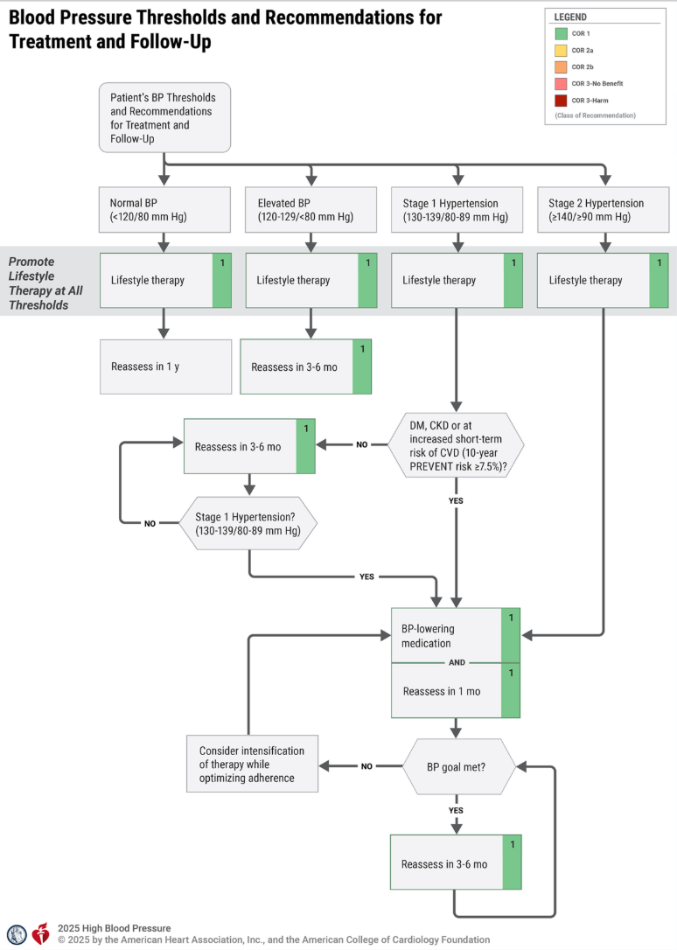
Appendix F. Hypertension Medications with Potential Dental Treatment Interactions
Medication, generic (trade) name | Adverse effects | Potential treatment interactions
Note: NSAIDS = non-steroidal anti-inflammatory drugs.
Primary agents
Angiotensin-converting enzyme inhibitors
Benazepril (Lotensin), captopril (Capoten), enalapril (Vasotec), fosinopril (Monopril), lisinopril (Prinivil, Zestril), moexipril (Univasc), perindopril (Aceon), quinapril (Accupril), ramipril (Altace) | Xerostomia, dysgeusia, ageusia, lichenoid reactions, rash, dry cough, angioedema, burning mouth, gingival bleeding, neutropenia | NSAIDs/orthostatic hypotension
Angiotensin receptor blockers
Candesartan (Atacand), eprosartan vasoconstrictor (Teveten), irbesartan (Cozaar), olmesartan (Benicar), telmisartan (Micardis), valsartan (Diovan) | Xerostomia, dysgeusia, angioedema, sinusitis, cough | Systemic antifungals, sedatives/orthostatic hypotension
Calcium channel blockers
Nondihydropyridines: diltiazem (Cardizem), verapamil (Calan)  Dihydropyridines: amlodipine (Norvasc), felodipine (Plendil), isradipine (DynaCirc), nicardipine (Cardene), nifedipine (Procardia), nisoldipine (Sular) | Xerostomia, gingival hyperplasia, dysgeusia, erythema multiform | Macrolide antibiotics, NSAIDS
Thiazide diuretics
Chlorothiazide (Diuril), chlorthalidone, hydrochlorothiazide (HydroDIURIL, Microzide), indapamide (Lozol), metolazone (Mykrox, Zaroxolyn), polythiazide (Renese) | Xerostomia, lichenoid reactions | NSAIDS, epinephrine/orthostatic hypotension
Secondary agents
Beta blockers
Cardioselective - acebutolol (Sectral), atenolol (Tenormin), betaxolol (Kerlone), bisoprolol (Zebeta), metoprolol (Lopressor) | Xerostomia
Noncardioselective - carteolol (Cartrol), nadolol (Corgard), penbutolol (Levatol), pindolol (Visken), propranolol (Inderal), timolol (Blocadren) | Xerostomia, dysgeusia, lichenoid reactions | NSAIDs, epinephrine
Alpha 1 blockers
Doxazosin (Catapres), prazosin (Minipress), terazosin (Hytrin) | Xerostomia, Dysgeusia | NSAIDS/orthostatic hypotension
Combined alpha/beta blockers
Carvedilol (Coreg), labetalol (Normodyne, Trandate) | Dysgeusia | NSAIDS/orthostatic hypotension
Central-acting agents
Clonidine (Catapres), guanfacine (Tenex), methyldopa (Aldomet), reserpine | Xerostomia, dysgeusia, lichenoid reactions (specific to methyldopa), sedation, parotid pain | Orthostatic hypotension
Direct-acting vasodilators
Hydralazine (Apresoline), minoxidil (Loniten) | Lupus-like oral and skin lesions, lymphadenopathy, gingival bleeding, infections, facial flushing | NSAIDS/orthostatic hypotension

Appendix G. Community-based Screening through Delivery Systems
(based off Cancer Commission Standards for Cancer Screening)
Definition and Requirements
Blood pressure screening, as part of other preventive screening events or independently, detects increased blood pressure which offers opportunity to intervene early on to address blood pressure and It is recommended that each health system organization, through partnering with community organizations, host events focused on preventive screening including but not limited to blood pressure. Examples of community organizations include, but are not limited to, religious institutions, schools, health districts, local gyms, and others.
The event should be based on evidence-based national guidelines and interventions, where applicable, and have a formal process for follow up on all positive screening. Resources for evidence-based national guidelines and interventions include but are not limited to:
- American Heart Association
- American Medical Association
- Agency for Healthcare Research and Quality
- United States Preventive Task Force
Examples of non-compliant programs/events include, but are not limited to:
- Screening programs performed in the regular course of business
- Events or programs that educate about blood pressure screening or lifestyle interventions for heart disease but that do not provide an actual screening
Report
An event summary must be presented to and discussed with …. The summary must include the following information: the event site, the focus of screening activities (e.g., blood pressure only, blood pressure and diabetes, etc.), the partnering community organizations where applicable, data-driven identification of target audience for screening based on groups with lower than average blood pressure screening or blood pressure control rates, guidelines used in planning the screening event, the detailed process for follow up based on screened blood pressure based on guidelines (e.g., protocols for emergency level blood pressure screening) While it is encouraged that cancer programs hold as many screening events as appropriate for their needs, only one event is submitted for purposes of this standard.
Suggested Measures of Compliance
Each calendar year, the organization fulfills all of the compliance criteria:
- The organization offers at least one screening event annually.
- Blood pressure screening programs use validated blood pressure measuring devices
- Where applicable, the screening event is consistent with evidence-based national guidelines and interventions.
- The screening event has a process for follow up on all positive screening findings.
- A summary of the screening event is presented to the … and documentation is submitted.

References

Centers for Disease Control and Prevention. (2025, January 28). High blood pressure facts & statistics. https://www.cdc.gov/high-blood-pressure/data-research/facts-stats/index.html
Forde AT, Lewis TT, Kershaw KN, Bellamy SL, Diez Roux AV. Perceived Discrimination and Hypertension Risk Among Participants in the Multi-Ethnic Study of Atherosclerosis. J Am Heart Assoc. 2021 Feb;10(5):e019541. doi: 10.1161/JAHA.120.019541. Epub 2021 Feb 18. PMID: 33596667; PMCID: PMC8174295.
Mohottige D, Davenport CA, Bhavsar N, et al. Residential Structural Racism and Prevalence of Chronic Health Conditions. JAMA Netw Open. 2023;6(12):e2348914. doi:10.1001/jamanetworkopen.2023.48914
Dolezsar CM, McGrath JJ, Herzig AJM, Miller SB. Perceived racial discrimination and hypertension: a comprehensive systematic review. Health Psychol. 2014 Jan;33(1):20-34. doi: 10.1037/a0033718. PMID: 24417692; PMCID: PMC5756074.
Deo SV, Motairek I, Nasir K, et al. Association Between Historical Neighborhood Redlining and Cardiovascular Outcomes Among US Veterans With Atherosclerotic Cardiovascular Diseases. JAMA Netw Open. 2023;6(7):e2322727. doi:10.1001/jamanetworkopen.2023.22727
Churchwell, K., Elkind, M. S. V., Benjamin, R. M., Carson, A. P., Chang, E. K., Lawrence, W., Mills, A., Odom, T. M., Rodriguez, C. J., Rodriguez, F., Sanchez, E., Sharrief, A. Z., Sims, M., & Williams, O.; on behalf of the American Heart Association. (2020). Call to action: Structural racism as a fundamental driver of health disparities: A presidential advisory from the American Heart Association. Circulation, 142(24), e454–e468. https://doi.org/10.1161/CIR.0000000000000936
Centers for Disease Control and Prevention. (2025, January 3). High blood pressure facts. https://www.cdc.gov/high-blood-pressure/data-research/facts-stats/index.html
https://odphp.health.gov/healthypeople/objectives-and-data/browse-objectives/heart-disease-and-stroke/increase-control-high-blood-pressure-adults-hds-05/data?group=Obesity%20status%20(20%20years%20and%20over)&from=2017&to=2020&state=United%20States&populations=#edit-submit
Vogel MT, Petrescu-Prahova M, Steinman L, et al. Partnerships for Blood Pressure Control in Washington State, December 2016-July 2017. Health Promot Pract. 2021;22(1):52-62. doi:10.1177/1524839919853819
Fryar CD, Ostchega Y, Hales CM, Zhang G, Kruszon-Moran D. Hypertension Prevalence and Control Among Adults: United States, 2015-2016. NCHS Data Brief. 2017;(289):1-8.
Aggarwal R, Chiu N, Wadhera RK, Moran AE, Raber I, Shen C, Yeh RW, Kazi DS. Racial/Ethnic Disparities in Hypertension Prevalence, Awareness, Treatment, and Control in the United States, 2013 to 2018. Hypertension. 2021 Dec;78(6):1719-1726. doi: 10.1161/HYPERTENSIONAHA.121.17570. Epub 2021 Aug 9. PMID: 34365809; PMCID: PMC10861176.
Centers for Disease Control and Prevention. (2025, March 20). Prevalence, awareness, and control of hypertension among adults with and without disabilities — United States, August 2021–August 2023. https://www.cdc.gov/eis-conference/php/media-resources/hypertension-among-adults.html
Chobufo MD, Gayam V, Soluny J, Rahman EU, Enoru S, Foryoung JB, Agbor VN, Dufresne A, Nfor T. Prevalence and control rates of hypertension in the USA: 2017-2018. Int J Cardiol Hypertens. 2020 Jul 31;6:100044. doi: 10.1016/j.ijchy.2020.100044. PMID: 33447770; PMCID: PMC7803011.
Chobufo MD, Gayam V, Soluny J, Rahman EU, Enoru S, Foryoung JB, Agbor VN, Dufresne A, Nfor T. Prevalence and control rates of hypertension in the USA: 2017-2018. Int J Cardiol Hypertens. 2020 Jul 31;6:100044. doi: 10.1016/j.ijchy.2020.100044. PMID: 33447770; PMCID: PMC7803011.
Samanic CM, Barbour KE, Liu Y, et al. Prevalence of Self-Reported Hypertension and Antihypertensive Medication Use by County and Rural-Urban Classification — United States, 2017. MMWR Morb Mortal Wkly Rep 2020;69:533–539. DOI: http://dx.doi.org.offcampus.lib.washington.edu/10.15585/mmwr.mm6918a1
Hardy, S. T., Fontil, V., Dillon, G. H., & Shimbo, D. (2024). Achieving equity in hypertension: A review of current efforts by the American Heart Association. Hypertension, 81(11), 2218-2227. https://doi.org/10.1161/HYPERTENSIONAHA.124.20533
Zhao Y, Bao WW, Yang BY, Liang JH, Gui ZH, Huang S, Chen YC, Dong GH, Chen YJ. Association between greenspace and blood pressure: A systematic review and meta-analysis. Sci Total Environ. 2022 Apr 15;817:152513. doi: 10.1016/j.scitotenv.2021.152513. Epub 2022 Jan 10. PMID: 35016929.
Suarez JJ, Isakova T, Anderson CA, Boulware LE, Wolf M, Scialla JJ. Food Access, Chronic Kidney Disease, and Hypertension in the U.S. Am J Prev Med. 2015 Dec;49(6):912-20. doi: 10.1016/j.amepre.2015.07.017. PMID: 26590940; PMCID: PMC4656149.
Reaume M, Labossière MN, Batista R, et al. Patient-Physician Language Concordance and Cardiovascular Outcomes Among Patients With Hypertension. JAMA Netw Open. 2025;8(2):e2460551. doi:10.1001/jamanetworkopen.2024.60551
Centers for Disease Control and Prevention. (2023). Excess burden of poverty and hypertension, by race and ethnicity, on the prevalence of cardiovascular disease. Preventing Chronic Disease, 20, E65. Retrieved from https://www.cdc.gov/pcd/issues/2023/23_0065.htm
Centers for Disease Control and Prevention. (2020). Hypertension prevalence and control among adults: United States, 2015-2016. NCHS Data Brief, (364). Retrieved from [https://www.cdc.gov/nchs/data/databriefs/db364-h.pdf[1](https://www.cdc.gov/nchs/data/databriefs/db364-h.pdf%5B1)]
Centers for Disease Control and Prevention. (2020). Hypertension prevalence and control among adults: United States, 2015-2016. NCHS Data Brief, (364). Retrieved from [https://www.cdc.gov/nchs/data/databriefs/db364-h.pdf[1](https://www.cdc.gov/nchs/data/databriefs/db364-h.pdf%5B1)]
Abrahamowicz, A. A., Ebinger, J., Whelton, S. P., Commodore-Mensah, Y., Yang, E., et al. (2023). Racial and Ethnic Disparities in Hypertension: Barriers and Opportunities to Improve Blood Pressure Control. Current Cardiology Reports, 25, 17-27. https://doi.org/10.1007/s11886-022-01826-x
Liu M, Marinacci LX, Joynt Maddox KE, Wadhera RK. Cardiovascular Health Among Rural and Urban US Adults—Healthcare, Lifestyle, and Social Factors. JAMA Cardiol. Published online March 31, 2025. doi:10.1001/jamacardio.2025.0538
Zhang D, Lee JS, Pollack LM, et al. Association of Economic Policies With Hypertension Management and Control: A Systematic Review. JAMA Health Forum. 2024;5(2):e235231. doi:10.1001/jamahealthforum.2023.5231
David L. Hare, Samia R. Toukhsati, Peter Johansson, Tiny Jaarsma, Depression and cardiovascular disease: a clinical review, European Heart Journal, Volume 35, Issue 21, 1 June 2014, Pages 1365–1372, https://doi.org/10.1093/eurheartj/eht462
Breeden, M., Gillis, A., Salas, J., & Scherrer, J. F. (2022). Antidepressant treatment and blood pressure control in patients with comorbid depression and treatment resistant hypertension. Journal of Psychosomatic Research, 153, 110692. https://doi.org/10.1016/j.jpsychores.2021.110692
Christoffer Polcwiartek, Kevin O’Gallagher, Daniel J Friedman, Christoph U Correll, Marco Solmi, Svend Eggert Jensen, René Ernst Nielsen, Severe mental illness: cardiovascular risk assessment and management, European Heart Journal, Volume 45, Issue 12, 21 March 2024, Pages 987–997, https://doi.org/10.1093/eurheartj/ehae054
Cecchini, M., Filippini, T., Whelton, P. K., Iamandii, I., Di Federico, S., Boriani, G., & Vinceti, M. (2023). Alcohol intake and risk of hypertension: A systematic review and dose-response meta-analysis of nonexperimental cohort studies. [Journal Name], [Volume](Issue), pages. https://doi.org/[DOI
Tsai SY, Huang WH, Chan HL, Hwang LC. The role of smoking cessation programs in lowering blood pressure: A retrospective cohort study. Tob Induc Dis. 2021 Oct 22;19:82. doi: 10.18332/tid/142664. PMID: 34720797; PMCID: PMC8534426.
Engström, S., Berne, C., Gahnberg, L. et al. Efficacy of screening for high blood pressure in dental health care. BMC Public Health 11, 194 (2011). https://doi.org/10.1186/1471-2458-11-194
Aggarwal, R., Chiu, N., Wadhera, R. K., Moran, A. E., Raber, I., Shen, C., ... & Kazi, D. S. (2019). Racial/ethnic disparities in hypertension prevalence, awareness, treatment, and control in the United States, 2013–2018. Journal of the American College of Cardiology, 73(23), 3106–3115. https://doi.org/10.1016/j.jacc.2019.04.042
Victor, R. G., Ravenell, J. E., Freeman, A., Leonard, D., Bhat, D. G., Shafiq, M., ... & Haley, R. W. (2011). Effectiveness of a barber-based intervention for improving hypertension control in Black men: The BARBER-1 study: A cluster randomized trial. Archives of Internal Medicine, 171(4), 342–350. https://doi.org/10.1001/archinternmed.2010.390
Mills KT, Obst KM, Shen W, Molina S, Zhang HJ, He H, Cooper LA, He J. Comparative Effectiveness of Implementation Strategies for Blood Pressure Control in Hypertensive Patients: A Systematic Review and Meta-analysis. Ann Intern Med. 2018 Jan 16;168(2):110-120. doi: 10.7326/M17-1805. Epub 2017 Dec 26. PMID: 29277852; PMCID: PMC5788021.
Pasha M, Brewer LC, Sennhauser S, Alsawas M, Murad MH. Health Care Delivery Interventions for Hypertension Management in Underserved Populations in the United States: A Systematic Review. Hypertension. 2021 Sep;78(4):955-965. doi: 10.1161/HYPERTENSIONAHA.120.15946. Epub 2021 Aug 15. PMID: 34397275.
https://www.cdnetwork.org/wp-content/uploads/2017/12/2017-Hypertension-Team-Statements.pdf
i, E., Clarke, J., Ashrafian, H., Darzi, A., & Neves, A. L. (2022). The impact of electronic health record interoperability on safety and quality of care in high-income countries: Systematic review. Journal of Medical Internet Research, 24(9), e38144. https://doi.org/10.2196/38144
Chen, M., Guo, S., & Tan, X. (2019). Does health information exchange improve patient outcomes? Empirical evidence from Florida hospitals. Health Affairs, 38(2), 197–204. https://doi.org/10.1377/hlthaff.2018.05447
Leao, D.L.L., Moers, L.A.M., Cremers, HP. et al. Design, implementation and evaluation of value-based payment models: a Delphi study. BMC Health Serv Res 25, 116 (2025). https://doi.org/10.1186/s12913-025-12281-z
American Heart Association. (2024). 2023–2024 Washington community impact highlights. American Heart Association. Retrieved September 10, 2025, from https://www.heart.org/-/media/Files/Affiliates/Regional-Pages/Washington/Community-Impact/2023-2024-WA-Community-Impact-Highlights.pdf\?utm_source\=chatgpt.com
Centers for Disease Control and Prevention. (2025, January 28). High blood pressure facts. U.S. Department of Health and Human Services. Retrieved September 10, 2025, from https://www.cdc.gov/high-blood-pressure/data-research/facts-stats/index.html
U.S. Department of Health and Human Services, Office of Disease Prevention and Health Promotion. (n.d.). Increase control of high blood pressure in adults (HDS-05): Data. Healthy People 2030. Retrieved September 10, 2025, from https://odphp.health.gov/healthypeople/objectives-and-data/browse-objectives/heart-disease-and-stroke/increase-control-high-blood-pressure-adults-hds-05/data
Vogel MT, Petrescu-Prahova M, Steinman L, et al. Partnerships for Blood Pressure Control in Washington State, December 2016-July 2017. Health Promot Pract. 2021;22(1):52-62. doi:10.1177/1524839919853819
Fryar CD, Ostchega Y, Hales CM, Zhang G, Kruszon-Moran D. Hypertension Prevalence and Control Among Adults: United States, 2015-2016. NCHS Data Brief. 2017;(289):1-8.
Vogel MT, Petrescu-Prahova M, Steinman L, et al. Partnerships for Blood Pressure Control in Washington State, December 2016-July 2017. Health Promot Pract. 2021;22(1):52-62. doi:10.1177/1524839919853819
Brownstein JN, Chowdhury FM, Norris SL, et al. Effectiveness of Community Health Workers in the Care of People with Hypertension. Am J Prev Med. 2007;32(5):435-447. doi:10.1016/j.amepre.2007.01.011
Vogel MT, Petrescu-Prahova M, Steinman L, et al. Partnerships for Blood Pressure Control in Washington State, December 2016-July 2017. Health Promot Pract. 2021;22(1):52-62. doi:10.1177/1524839919853819
Ostchega Y, Fryar CD, Nwankwo T, Nguyen DT. Hypertension Prevalence Among Adults Aged 18 and Over: United States, 2017-2018. NCHS Data Brief. 2020;(364):1-8.
Schoenthaler, EdD A, Lancaster, PhD K, Midberry, Mph S, et al. The FAITH Trial: Baseline Characteristics of a Church-based Trial to Improve Blood Pressure Control in Blacks. Ethn Dis. 2015;25(3):337. doi:10.18865/ed.25.3.337

