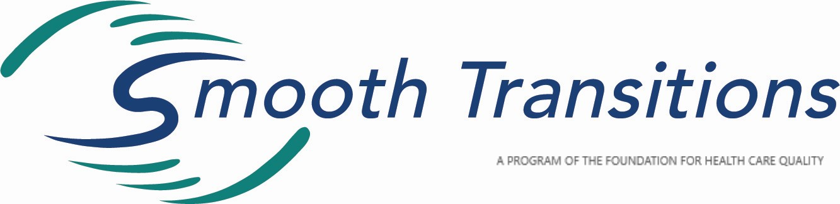
Information Sheet
The Smooth Transitions™ Quality Improvement Program was originally conceived under the auspices of the Washington State Perinatal Collaborative as an initiative to enhance the safety of hospital transfers from planned community-based births.
In 2009, the MD/LM Workgroup, a subcommittee of the WA State Department of Health Perinatal Advisory Committee, introduced the program to assist hospitals providing obstetrical services, and their local community midwives, in developing clear protocols to facilitate seamless transfers of care for gestational parents or newborns from the home or birth center setting when they need to access hospital services.
Since January 2018, Smooth Transitions has been under the umbrella of the Foundation for Health Care Quality (FHCQ), a neutral 501(c)3 organization in Seattle that houses several other quality improvement programs, including the Obstetrical Care Outcome Assessment Program (OB COAP). This move to the FHCQ re-energized and re-focused the program. Smooth Transitions now has more administrative support, a prominent web presence, CQIP status (which will allow for inter-professional protected case review), and a sophisticated level of data collection and analysis. Smooth Transitions is led by an enthusiastic, multidisciplinary Leadership Team that meets quarterly.
The goals of the program are to:
- Improve whole person safety* and efficiency of the transfer process through the establishment of system-wide protocols
- Collect and analyze transfer outcome data for the purpose of quality improvement
- Build greater collaboration between community midwives, EMS, and the hospital care team
- Enhance the patient experience of care when transfers occur
Smooth Transitions has received financial and in-kind support from a number of stakeholder groups, including the Washington State Hospital Association, the Washington State Obstetric Association, the state affiliate of the American College of Nurse-Midwives, the Midwives’ Association of Washington State, the Washington Alliance for Responsible Midwifery, the OB Hospitalist Group. Smooth Transitions has also received grants from the American Institute for Research, The Yellow Chair Foundation, and the Washington State Department of Health.
Nearly half of the hospitals throughout the state have received presentations or expressed interest in the program. The Smooth Transitions leadership team has also presented at a number of perinatal collaborative meetings in other states and at the International Confederation of Midwives Triennial Congress in Toronto. Participating hospitals in Washington are engaged at various levels: some have only received an initial presentation; others have formed Perinatal Transfer Committees, developed clear transfer protocols and are meeting regularly with local community midwives, problem-solving together, and collecting data.
How To Get Started
Hospitals interested in learning more about the Smooth Transitions™ QI Program should contact the Program Coordinator (smoothtransitions@qualityhealth.org) to set up a 90-minute informational meeting with your obstetrical and pediatric service teams to introduce the program. At this meeting, representatives from the Smooth Transitions Leadership Team will present and answer questions about the program; then, if the hospital decides to move forward with next steps, the Program Coordinator will be available to provide ongoing consultation and support throughout the process.
The expectation is that each participating hospital will identify clinician champions, both in the hospital and in the midwifery community, and set up a Perinatal Transfer Committee (PTC). This committee ideally will include obstetrical staff, OB nursing leadership, pediatric staff, and representatives from patient safety/risk management departments, as well as local EMS providers and licensed midwives who transfer to that hospital. At a minimum, the PTC develops a transfer protocol and creates other transfer tools as needed. This committee will meet regularly to share updates, discuss any issues or concerns regarding transfers, and to work on strategies to improve efficiency, safety, and patient satisfaction. Both quantitative and qualitative data are collected on the transfers and then discussed at the PTC meetings. Participating hospitals and community midwives are also asked to submit a brief annual audit to the Smooth Transitions Leadership Team about the program’s impact. If needed, one benefit of program participation is the ability to engage in a protected case review process under the Department of Health’s Coordinated Quality Improvement Program (CQIP).
Smooth Transitions Program Steps
- Host a Smooth Transitions™ Presentation
The Smooth Transitions Program Coordinator sets up a presentation at your hospital. Beforehand, the Program Coordinator talks with hospital staff and community midwives about the current situation and issues.
- Identify Clinician Champions
It is important to find clinician champions for both the hospital and midwifery community. They will help organize meetings, communicate between the groups and with the program coordinator.
- Form a Perinatal Transfer Committee (PTC)
Gather a group of obstetrical and pediatric providers, nursing staff, EMS personnel, and local community midwives and form a Perinatal Transfer Committee (PTC) that meets regularly.
- Develop Transfer Tools and Resources
The PTC creates a transfer protocol and other needed transfer tools such as: forms, SBAR scripts, and transfer algorithms.
- Meet Regularly/Interaction
The PTC meets at least ~4x/year to share updates, discuss any issues or concerns regarding transfers, and to work on strategies to improve efficiency, safety, and satisfaction. This can also be an opportunity to provide/develop needed CME, skills training, and resources. Protected case reviews can occur as needed following the Smooth Transitions Protocol.
- Collect Data and Publish Research Participating hospitals and community midwives will collect data to evaluate the efficacy of the project. Quantitative and qualitative analysis can be done for small scale improvement at the hospital level or statewide for research purposes and publication.

