Organization type: Inpatient acute care hospital

Organization department or site (if applicable): Family Birth Center

*Description of awards process:*

We will convene a panel of judges from a diverse group of organizations that represent patients or other health care users and Bree stakeholders to review the awards submissions.

The panel members are blinded to the identity of the organizations and score each on both qualitative and quantitative criteria. Quantitative criteria include self-report score cards. Qualitative criteria include the questions on this form (below) and review of supporting documentation. Judges will be asked to rate your work on impact, patient satisfaction, comprehensiveness of strategies, adequacy of accountability processes, effectiveness of addressing Social Drivers of Health, and adaptability (to other organizations or programs).

FHCQ will post deadlines and award focus area timelines for each awards period on the FHCQ website and provide deadline information to nominees.

*Definition of implementation:*

Implementation means use of a guideline in part or full during clinical practice, health care contracting, policy making, educational programs, or other health care related activities; and/or use of guidelines to fulfill elements of an initiative, regulation, or requirements.

**Please indicate the health care service for which Bree Collaborative has developed guidelines to be considered. This work should exemplify efforts in creating EQUITY within a single service line, program, or policy. Please make sure that all of your answers are de-identified. We will use the information at the top to link your information to your organization once**

*Perinatal Behavioral Health*

**Overall description of project:**

We have implemented a best practice bundle for all inpatients surrounding assessment of and care for patients experiencing perinatal mood and anxiety disorders that includes 3 elements:

1. Every patient is assessed with the Edinburg Postnatal Depression Screening tool within 12 hours of discharge.
2. For patients with scores of 10 or above or answer “Yes” to question 10:
   1. Social Work consult is completed prior to discharge
   2. The attending provider is notified and to create collaborative plan of care with patient prior to discharge
3. All patients will receive education about perinatal mood and anxiety disorder prior to discharge.

**Q1)** How did your organization measure change in ***equity for the health outcomes*** *for* the topic the organization sought to address?

1. What metrics did you use?
   1. We are using bundle compliance as our metric. Compliance is measured as ALL bundle elements being completed prior to discharge.
2. How did you revise or stratify these metrics to provide a better view of equity?
   1. We are working to stratify this data across race and ethnicity and primary language spoken
3. How did you determine appropriate benchmarks?
   1. Our ultimate goal is an average of 90% compliance over 12 months overall, as well as in each race/ethnicity category.

**Q2)** How did your organization measure patient satisfaction?

1. What metrics did you use? Patient experience scores
2. What survey methods did you use? HCAPs surveys post discharge

**Q3)** How does your organization maintain accountability for equity within the program for the following areas:

1. Communication - the screening tool and education provided to patients are available in 30+ languages, and it is required that when discussing/providing education the staff use an interpreter for any patient that is not English speaking.
   1. In communication about the program with staff and leadership
   2. In communication about the program with patients and families
   3. In communication about the program with community
2. Education and training
   1. Ongoing training for use of the tool and PMAD education are provided to staff monthly along with transparency around compliance rates and goals.
3. Through policies, procedures, or activities
   1. Our policy supporting this project is titled “Perinatal Mood Anxiety Disorder and Suicide Risk Screening in the Family Birth Center” (see copy attached). It outlines how to screen, what actions to take based on the result, and what education is required for EVERY patient.

**Q4)** How did your organization address social drivers of health? (list all that apply)

1. In workforce hiring, training, and development
   1. Pathways (online) education modules assigned to all staff about perinatal mental health and social drivers of health, system wide townhalls held via webinar for all staff, EMR education provided in person, via email, via tipsheets, and in staff meetings.
2. With programs and/or policies changes
   1. Staff meetings held to roll out and educate about new policy to address perinatal mental health assessment and treatment quality bundle
3. What measures did your organization use to evaluate the effectiveness of the efforts to address social needs?
   1. Data pulled from the EMR in real time as well as retrospective data and chart review done for all fallout cases in which we did not meet the standards of assessment, treatment, and providing support prior to discharge.

**Q5)** What strategies did your organization use to:

1. To understand patient needs
2. To develop community partnerships
3. To address power imbalances

**Q6)** Describe the ease of implementation in embedding equity into this program. What helped facilitate an equitable approach to the development or improvement of this program? (e.g. staffing diversity, leadership buy-in, community feedback, regulatory changes, funding changes, etc.)

What were some of the main barriers to success in your setting?

1. Barrier 1 –
   1. What was it? Staff buy in
   2. How did you identify it? Townhalls, in person rounding, staff meetings
   3. How did you address it? Just in time teaching, providing evidence that supports this practice, discussing in meetings the impact this has on patients
2. Barrier 2 –
   1. What was it? Resource availability: social work
   2. How did you identify it? delays in social work consults, documentation not in real time
   3. How did you address it? collaborated with social work department to create plan for how to mobilize resources available, and prioritize patients being seen before discharge
3. Barrier 3 –
   1. What was it? Documentation: multiple places to document care, missing documentation
   2. How did you identify it? missing documentation, or unable to pull data from discrete fields requiring manual chart review for compliance
   3. How did you address it? Staff education in meetings, tipsheets placed on unit and emailed to staff, discussion during safety huddles, closing the loop for any fallout cases via both one on one discussion and email

**Q7)** Please include other information that you believe made this project successful in terms of equity. You may want to consider such aspects as types of staff education, changes in workflows, use of data, culture change work, details on payment or contracting solutions, collaborations, etc.

**Examples**: It is helpful to attach any examples of documents relevant to your project such as screen shots, workflow map, policy language, contract language, process prompts, posters, communication language, etc.) These can be attached in the email or attached through the submission portal. In previous years, successful applicants have attached charts and graphs, screen shots, sample documents as examples. *Please make sure that your examples are de-identified.*

Please see following attachments:

Perinatal Mood Anxiety Disorder and Suicide Risk Screening in the Family Birth Center policy

Patient Suicide Safety Plan template

Edinburgh Postnatal Depression Scale Referral Algorithm

EPDS Screening tool implemented

Standardized PMAD Patient education materials

RN Documentation tipsheet

PMAD Bundle Compliance trends 2024

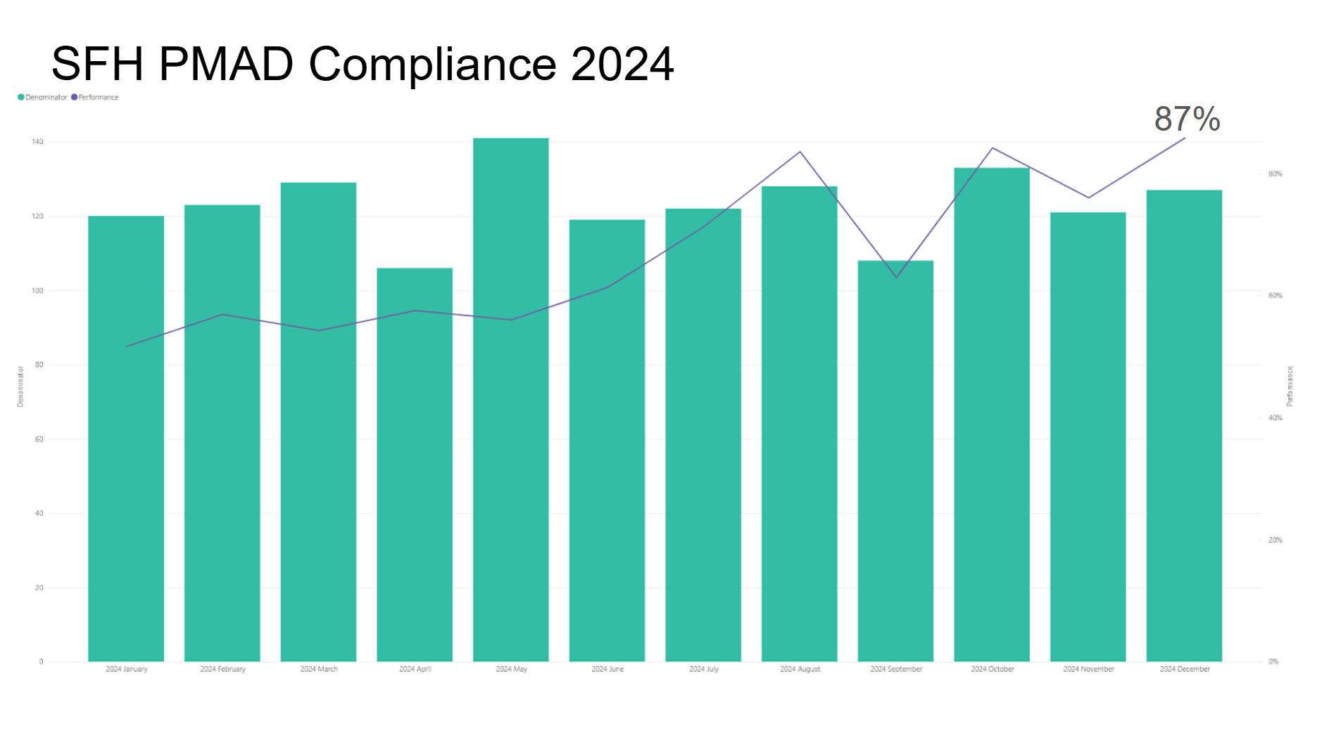

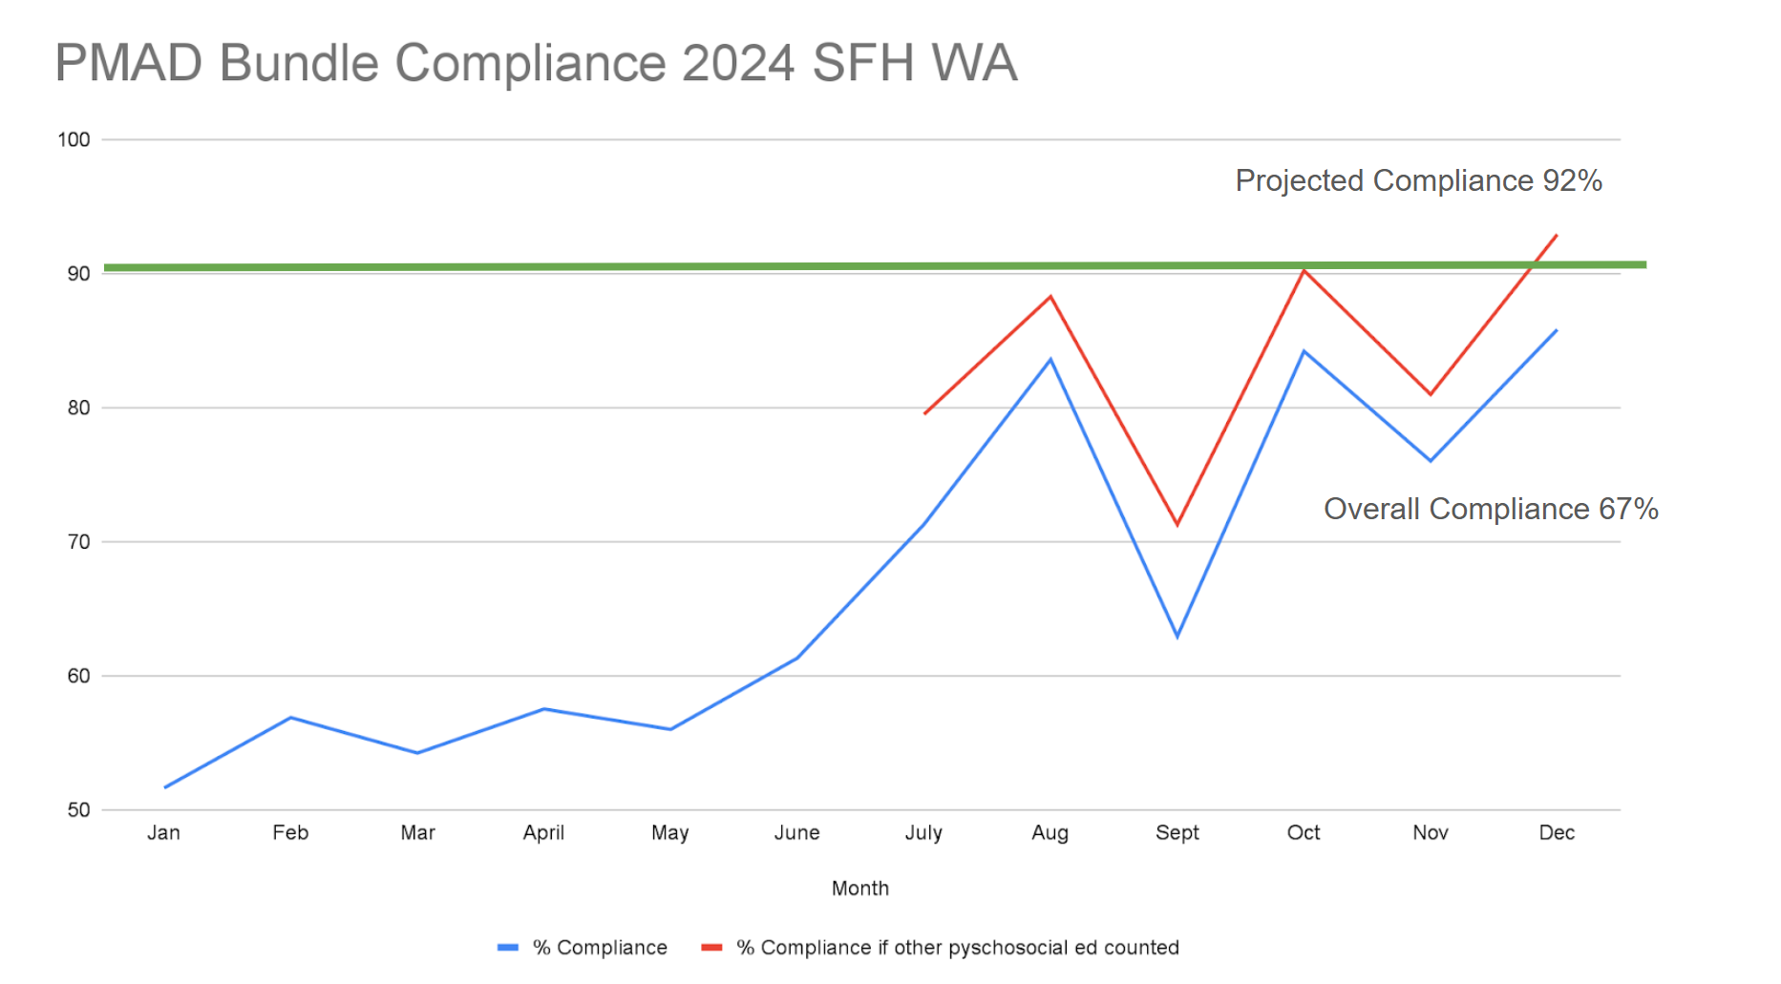

Example of loop closure email and conversation:

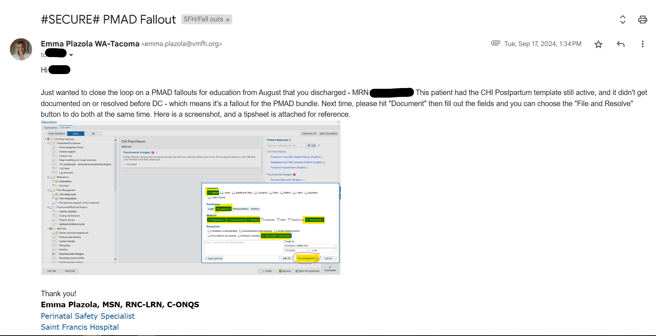

For FHCQ use only:

Nomination #