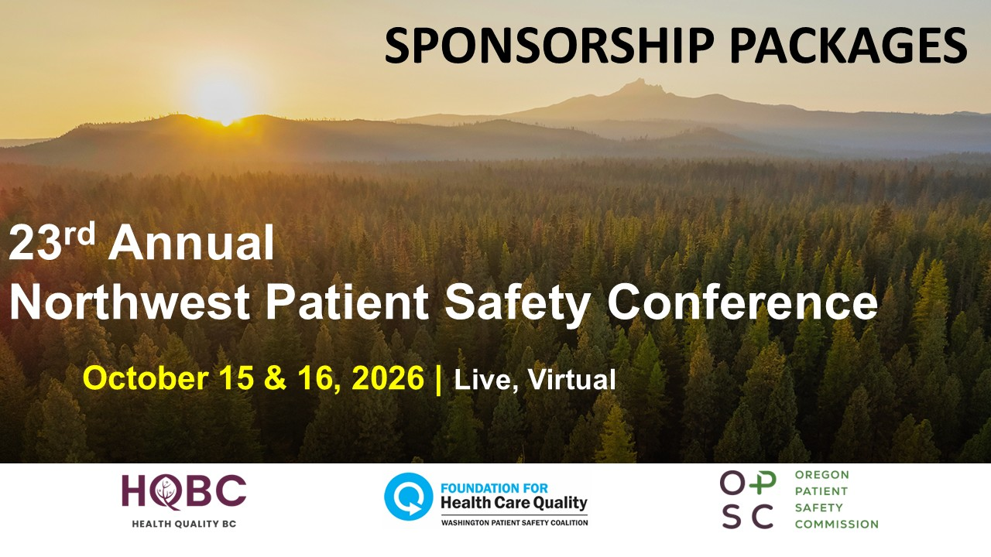
Safety by Choice, Not by Chance - Practical Tools to Elevate Patient Safety
The Washington Patient Safety Coalition is pleased to invite interested sponsors to support our 23rd annual conference October 15, 16, 2026. This is a live virtual event.
The Northwest Patient Safety Conference is an annual event that brings together over 500 healthcare leaders, staff and advocates from around North America.
Why sponsor?
- You have exceptional brand visibility to the decision makers who approve purchases: conference content and sponsor information is available for 1 year on-line.
- You have a great public relations opportunity to present a positive image to all major healthcare stakeholders and institutions, healthcare providers and public officials.
- Demonstrate your commitment to improving healthcare to your customers.

The 23rd NWPSC is a virtual conference in partnership with the Oregon Patient Safety Commission and Health Quality BC.

Program information is found on the conference website.

SPONSORSHIP PACKAGES INCLUDE SEVERAL SUGGESTED BENEFIT LEVELS and THE OPTION TO SPONSOR AT AN AMOUNT YOU PREFER

All sponsors will be recognized on the Washington Patient Safety Coalition website and marketing materials with sponsor logos linking to an external website. Platinum, Gold, Silver and Bronze sponsors have access to a dedicated page on the conference website which can include images, videos, links, etc. In addition to those benefits, each sponsorship level provides unique benefits, visibility, and marketing options.

Platinum Sponsor - $10,000 (1 Available - designation as Presenting sponsor)
- Platinum sponsorship will be considered a “presenting sponsor” of the conference and therefore will be listed on conference materials directly after the conference name Ex: “The 23rd Annual Northwest Patient Safety Conference Presented by:….”
- Recognition as Platinum Sponsor in all promotional material:
  - Lead position on all key marketing materials
  - Lead logo position in all sponsor lists
  - Logo listed as presenting sponsor on the event registration website
  - Conference platform visibility: Prominent logo placement on conference pages.
  - Dedicated sponsor page on the conference website
  - All conference announcements during the event will include your organization’s logo
- You will introduce the October 15th opening Keynote Speaker
- Fifteen (15) free registrations for the conference, a $1,275 value.
- Detailed attendee roster provided to sponsor prior to the event date
- ‘Sponsor spotlight’ feature and designation as Presenting Sponsor in Friday Five newsletter (1700 weekly recipients) and social media platforms
- Presenting Sponsor Designation and Logo placement on all material in perpetuity
- Logo placement in email reminder to attendees the week prior to the conference and post-conference survey email

Gold Sponsor(s) $7,500 (3 available)
- Recognition as Gold Sponsor in all promotional material:
  - Prominent position on all key marketing materials
  - Prominent logo placement in all sponsor lists
  - Half-page ad space in agenda
  - Logo listed as gold sponsor on the event registration website
  - Conference platform visibility: Prominent logo placement on conference pages.
  - Dedicated sponsor page on the conference website
- Introduction of Plenary Speaker (3 available) with your organization’s logo on the session webpage and a one-minute recorded pre-roll before the plenary speaker’s presentation starts
- Ten (10) free registrations to the conference, a $850 value.
- Detailed attendee roster provided to sponsor prior to the event date
- ‘Sponsor spotlight’ feature in Friday Five newsletter (1700 weekly recipients) and social media platforms

Silver Sponsor(s) $5,000
- Recognition as Silver Sponsor in all conference material:
  - Logo placement in all sponsor lists
  - Logo listed as silver sponsor on the event registration website
  - Conference platform visibility: Prominent logo placement on conference pages.
  - Dedicated sponsor page on the conference website
- Introduction of breakout room sessions with your organization’s logo on the session webpage and a one-minute recorded pre-roll before the breakout session begins.
- Seven (7 free registrations to the conference, a $595 value
- Detailed attendee roster provided to sponsor prior to the event date
- ‘Sponsor spotlight’ feature in Friday Five newsletter (1700 weekly recipients) and social media platforms

Bronze Sponsor(s) $2,500
- Recognition as Bronze Sponsor in conference material:
  - Logo placement in all sponsor lists
  - Logo listed as bronze sponsor on the event registration website
- Three (3) free registrations to the conference, a $255 value
- Conference platform visibility: Prominent logo placement on conference pages.
- Dedicated sponsor page on the conference website
- Detailed attendee roster provided to sponsor prior to the event date
- Logo in ‘Bronze Sponsor spotlight’ feature in Friday Five newsletter (1700 weekly recipients)
- Detailed attendee roster provided to sponsor prior to the event date

Supporter(s) of Patient Safety $1,500
- Recognition as Supporter of Patient Safety in conference materials
- Conference platform visibility: Logo placement on conference pages.
- Two (2) free registrations to the conference, a $170 value

Other Amount: See Form Below

Please use the form below to complete your sponsorship.

Because of you we can offer a conference of significant value with great accessibility.

*Newsletters go out Monthly. Number of e-mail blasts will be dependent upon timing of sponsorship agreement.

2026 SPONSORSHIP PACKAGES

Organization Information:
Note: Please complete this section with information as it should appear on promotional materials:
Full Organization Name:
Website:
Address:
☐ Logo attached ☐ Organization description attached ☐ Will send by:
Your logo will be displayed on conference webpages with an embedded link to, please select below
☐ a dedicated conference page with content of your choosing (Platinum, Gold, Silver and Bronze levels only) ☐ an external link of your choice, please include link (available to all levels).

Contact Information:

Lead Contact Name:
Title:
Email:
Phone Number:
Sponsor Level (Choose All That Apply):
☐ Gold Sponsor ($7,500) ☐ Supporter of Patient Safety ($1,500)
☐ Silver Sponsor ($5,000) ☐ Other Amount $_________
☐ Bronze Sponsor ($2,500)

Payment Options:
☐ Check enclosed ☐ Please invoice us ☐ Sending a check
Please email this form to:  Steve Levy, Executive Director  slevy@qualityhealth.org | And/or mail with check to:  ATTN: WPSC  Foundation for Healthcare Quality  400 University St. Suite 300  Seattle, WA 98101

